[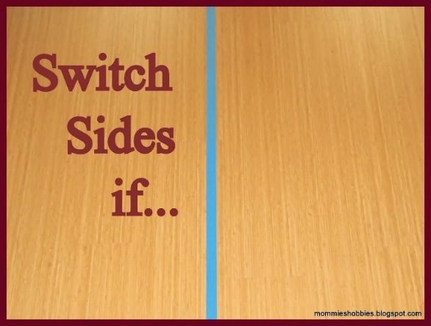](http://3.bp.blogspot.com/-l-UfzZPQ1oA/UtgccyjP-hI/AAAAAAAAAZo/pnerESBE-Tc/s1600/DSCN1594.JPG)

Have everyone stand on whatever side of the line they want (but the group should be basically divided in half).  Then ask everyone to “switch sides if” the statement applies to them.  After some of the statements, they should be asked to tell someone next to them a little more about themselves.

It's a lot of fun and gets everyone talking.  It is really interesting to see who switches sides on some of the statements and who has the same things in common with each other.

Here are some ideas for statements:

You like to go hiking.

You like to take trips.

You like to take trips with your family/ friends.

You prefer summer more than winter.

You were born in (the city where you live)…if you switch sides, tell someone where.

You prefer spring to fall.

You have lived in another country…if you switched sides, tell someone where.

You prefer pie over cake.

You have 4 or more siblings.

You prefer morning to night.

You were named after someone…if you switched sides, tell someone who.

You like to sing.

You like to help out at home.

You speak another language (besides English and Hebrew, of course)…if you switched sides tell someone what languages you speak.

You prefer mountains to the sea.

You play an instrument…if you switched sides tell someone what instrument you play.

You prefer dark chocolate to white chocolate.

You have traveled out of the country…if you switched sides tell someone where.

You like reading more than playing with friends.

You like to play with your cousins.

You like to do your homework.

You like to fly kites.

You like to ride bikes.

You like to build things.

You like learning Torah.

You like to play sports.

You like to watch sports.

You like to cook.

You like to sew.

You babysit a lot.

You prefer washing dishes to doing laundry.

You help your mother prepare for Shabbos…if you switched sides tell someone what you do.

The teacher can add sentences based on vocabulary or a grammar point the class has been studying.

For example:

(Modals)

You should go to bed by 10:00.

If you could you would buy your friend something she really wants. (Tell someone what.)

(Present Perfect)

You've never eaten lamb chops.

You've taken your younger siblings to school for years. (How old are they?)