**5777**

**What's Inside?**

**The Parshiot- page 2**

**Hints to Hanukah- pages 3- 6**

**Halachot for Hanukah- pages 7- 8**

**Fact File- page 9**

**Words of Torah- pages 10-12**

**Your New Words- pages 13-14**

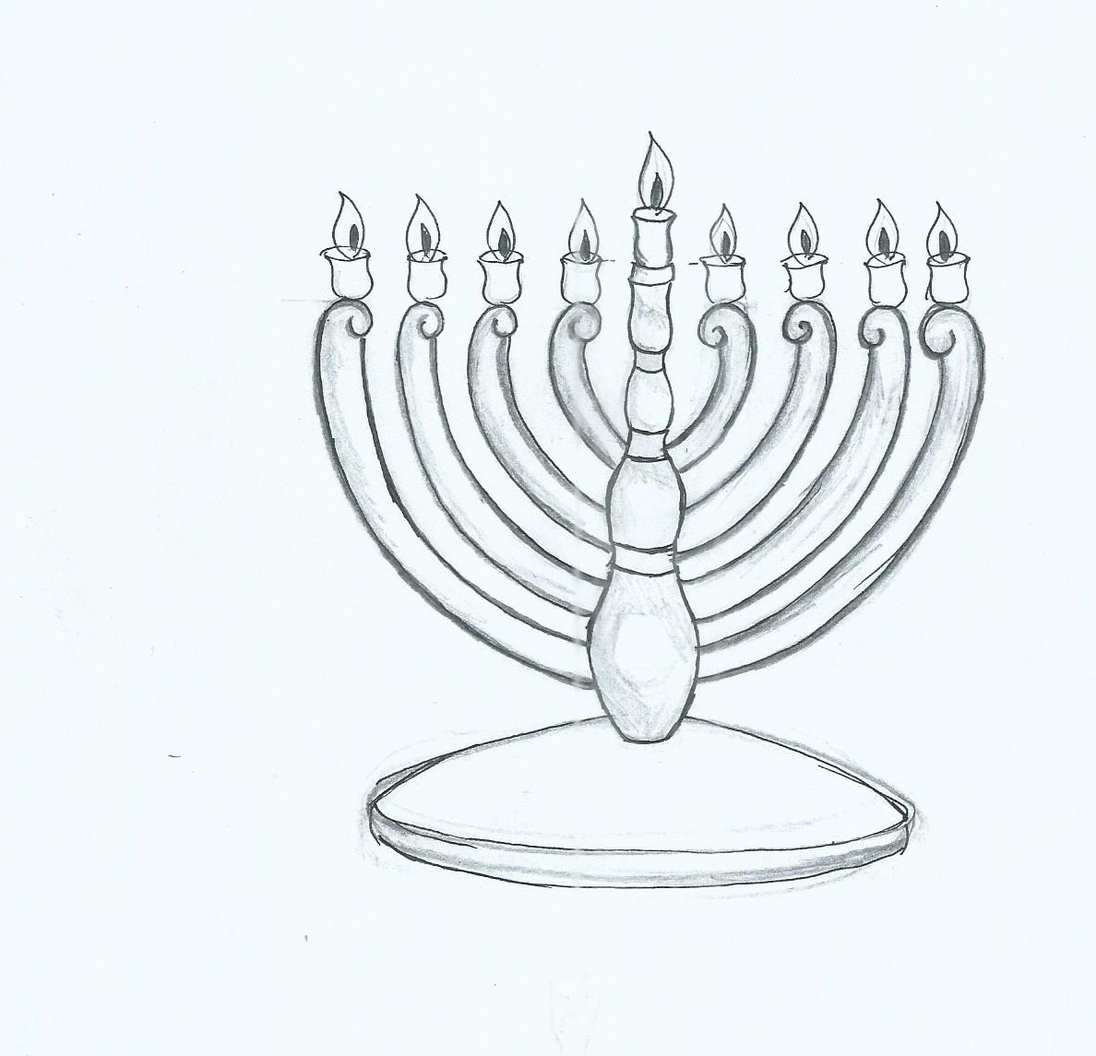

C:\Users\user\Documents\Scan0042 (2).jpg

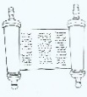

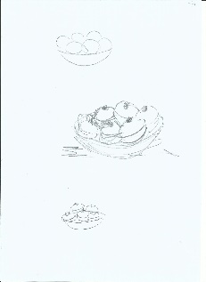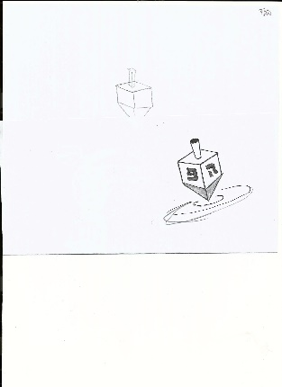

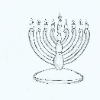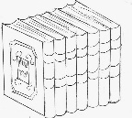

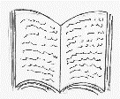

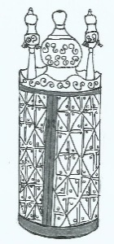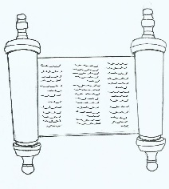The Parshiot of Kislev

Write the name of the parasha below its box.

The Parshiot:

|  |  |
| --- | --- |
| * Toldot * Vayetze | * Vayishlach * Vayeshev |

about- אודות, על

angel- מלאך

below- למטה

box- קופסה

brother- אח

dream (n)- חלום

dream (v)- לחלום

fight- מאבק

go down- לרדת

go up- לעלות

have (had)- יש ל...

his- שלו

its- שלו

ladder- סולם

name- שם

tell (told)- לספר

to- ל

twin- תאום

two- שתיים

with- עם

write- לכתוב

Yaakov had a fight with an angel.

The Parasha is__________________

Yosef had two dreams. He told them

to his brothers.

The Parasha is__________________

Yaakov dreamed about angels going up

and angels going down a ladder.

The Parasha is__________________

Rivka had twin boys.

The Parasha is__________________

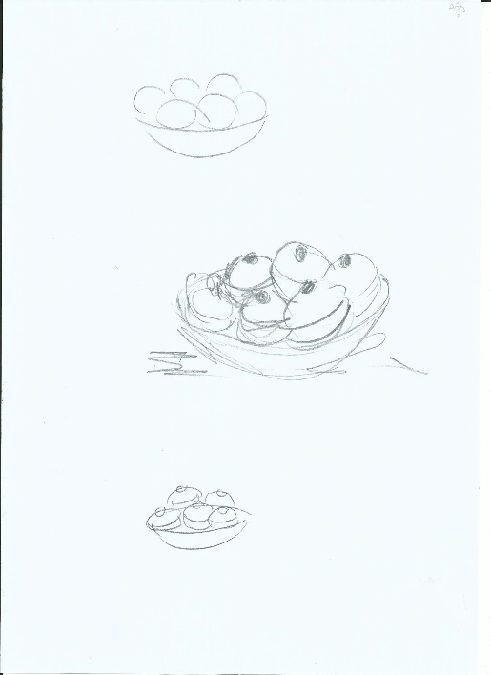

all- כל

amazing- מדהים

article- מאמר

below- למטה

class- שיעור

come back (came)- לחזור

dialogue- דו-שיח

fine-בסדר

from- מ...

hint- רמז

holiday- חג

just- רק

know- לדעת

learn- ללמוד

letter- מכתב

light- להדליק

like- כמו

list- רשימה

my- שלי

oil- שמן

right after- מיד אחרי

story- סיפור

that- ש

type- סוג

well- ובכן

letter

1. **Look at the text below. It is** _____.
2. a story
3. an article
4. a dialogue
5. a letter
6. **Now read the text between Ariel and Benny.**

**Your Glossary**

**about- אודות**

**add- להוסיף**

**another- אחר**

**can- יכול**

**fact- עובדה**

**holiday- חג, חופשה**

**month- חודש**

**of- של**

**year- שנה**

**other- אחר**

**there are- יש**

**what- מה, איזה**

Hints in the Torah

(Adapted from Sefer Hatodaah by Rav Eliyahu Ki Tov, p. 173)

Ariel: Shalom Benny, how are you?

Benny: I'm fine, Baruch Hashem. How are you?

Ariel: Great, Baruch Hashem. I just came back from my Torah class and I learned an amazing dvar Torah.

Benny: Like what?

Ariel: Well, do you know that there are hints in the Torah about Hanukah?

Benny: No, I don't know, where?

Ariel: Well, in parashat Emor the Torah writes a list of all the holidays: Shabbat, Pesach, Shavuot, Rosh Hashana, Yom Kippur and Sukkot. Well, right after Sukkot, the Torah writes about oil and lighting the ner tamid.

Benny: So?

awesome- מדהים

candle- נר

come- לבוא

desert- מדבר

evening- ערב

for- בשביל

I see- אני מבין

light- אור

listen- להקשיב

more- עוד

place- מקום

so- אז

there will be- יהיה

this- זה

travel- לנסוע

word- מילה

Ariel: This is a hint that there will be a holiday of lighting candles right after Sukkot…Hanukah!!!

Benny: Wow, that's amazing. Are there more hints?

Ariel: Yeah… do you know what the 25th word of the Torah is?

Benny: No… what is it?

Ariel: "Light".

Benny: Oh, I see… Hanukah is on the 25th of Kislev and the word "light" is the 25th word in the Torah. Awesome!

Ariel: Yeah, it is. Also, listen to this one. In Bamidar, in parashat Mas'ei, do you know the 25th place that Bnei Israel traveled to in the desert?

Benny: No, where?

Ariel: In Chashmona… Chashmona is a hint for Chashmonaim.

Benny: Wow, terrific. Hey,…when is that Torah class?

Ariel: On Thursday evenings at 7.

Benny: Bli neder I'm coming.

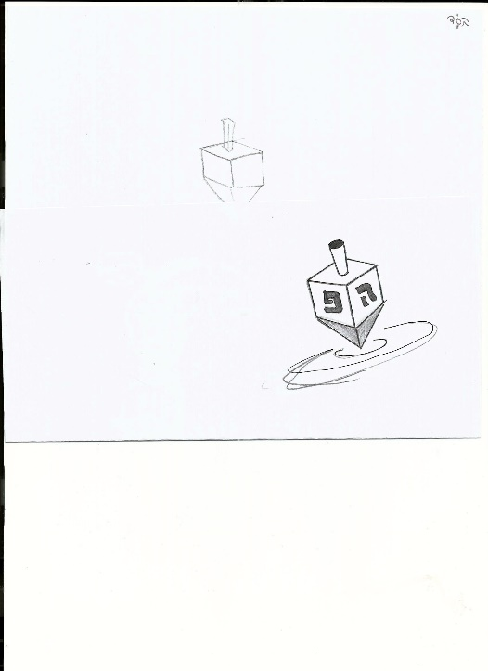Answer the questions.

at least- לפחות

chart- טבלה

class- שיעור

connection- קשר

fill in- למלא

interested- מעונין

learn- ללמוד

show- להראות

tell- לומר

word- מילה

1. Ariel learns in his Torah class about ____.
2. parashat Emor
3. where Bnei Yisrael traveled
4. Hanukah hints in the Torah
5. the holidays
6. Benny is interested in what Ariel is saying.

Write at least TWO words that show this.

1. …………………………………
2. …………………………………
3. …………………………………
4. …………………………………
5. Ariel tells about three hints in the Torah for Hanukah.

Fill in the chart.

|  |  |  |
| --- | --- | --- |
|  | **Hint in the Torah** | **Connection to Hanukah** |
|  |  |  |
|  |  |  |
|  |  |  |

**Unscramble** **the words. Copy the letters to the cells with the same** **number. You can use the words in the box below to help you.**

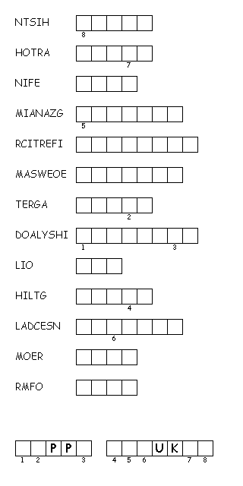

below- למטה

box- קופסה

can- יכול

cell- תא

copy- להעתיק

help- לעזור

hidden- חבוי

letter- אות

message- הודעה, מסר

same number- אותו מספר

unscramble- לפתור

use- להשתמש

**Hidden Message**

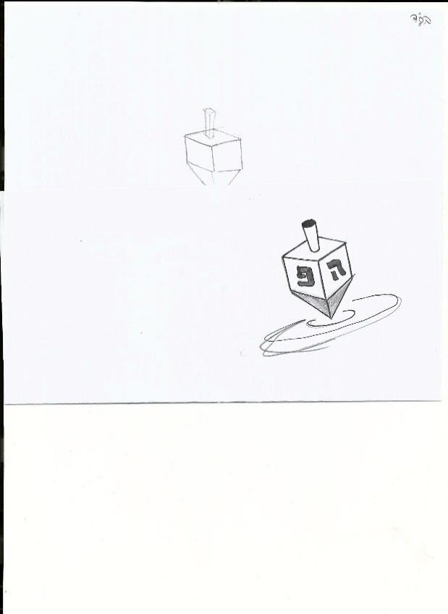

|  |  |
| --- | --- |
| amazing  awesome  candles  fine  from  great  hints | holidays  light  more  oil  terrific  Torah |

Write what you do for Hanukah. Use the words below to help you.

|  |  |  |  |  |  |  |
| --- | --- | --- | --- | --- | --- | --- |
| **1**   * I * We * My family * My father * My mother * My rebbe * Everyone | **┴** | **2**   * light(s) * use(s) * add(s) * say(s) * read(s) * don't do * doesn't do * ______ * ______ * ______ * ______ | **┴** | **3**   * (the) candles * one candle * Hallel * Torah * al hanissim * work * ______ * ______ * ______ * ______ * ______ | **┴** | * **4** * with oil. * with candles. * on wicks. * every night. * in the window. * in front of the door. * outside. * at sunset. * after maariv. * before maariv. * after the stars come out. * every day of Hanukah |

with- עם

oil- שמן

wick- פתיל

night- לילה

in front of- מול

outside- בחוץ

candle- נר

one- אחד

work- עבודה, מלאכה

I- אני

we- אנחנו

everyone- כל אחד

add- להוסיף

do- לעשות

light- להדליק

read- לקרוא

say- לומר

use- להשתמש



Write what you do.

What do you use to light the Hanukah candles?

add- להוסיף

can- יכול

candle- נר

has to- חייב

how- איך

light- להדליק

other- אחר

use- להשתמש

what- מה

when- מתי

where- איפה

who- מי

write- לכתוב

your- שלך

………………………………………………………………………………………………………………

How do you light the Hanukah candles?

…………………………………………………………………………………………………………

Where do you light the Hanukah candles?

………………………………………………………………………………………………………

When do you light the Hanukah candles?

…………………………………………………………………………………………………………

Who lights the Hanukah candles in your house?

…………………………………………………………………………………………………………

What minhagim can you add?

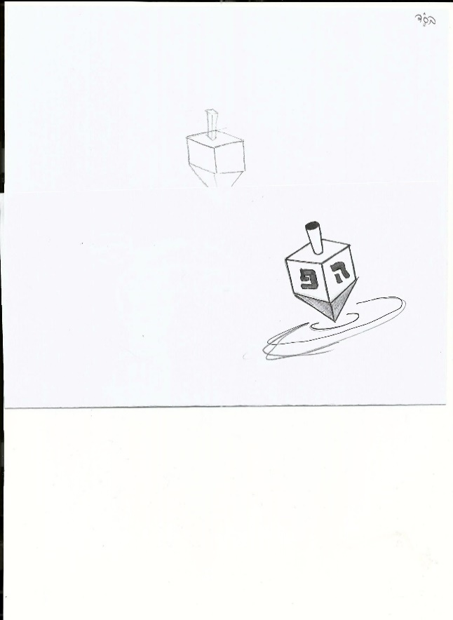………………………………………………………………………………………………………………

………………………………………………………………………………………………………………

………………………………………………………………………………………………………………

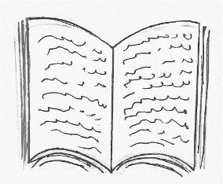**Fact File About a Famous Rabbi**

about- אודות

answer- לענות

around the world- סביב העולם

around- בערך

birth- לידה

book- ספר

called- נקרא

come(came)- לבוא

date -תאריך

died- נפטר

fact file- תיק עובדות

famous- מפורסם

get (got)- לקבל

happy- שמח

information- מידע

known as- ידוע כ...

many- הרבה

one of- אחד מ...

people- אנשים

question- שאלה

rabbi- רב

read- לקרוא

very- מאד

visit- לבקר

was born- נולד

were- היו

which- ש

why- למה

**Read the information about a famous rabbi.**

**BEN ISH HAI**

Rabbi Yosef Chaim ben Eliyah al-Chakam was born in Baghdad, around 1835. Many people came to hear Rabbi Yosef Chaim speak. He wrote many books about halacha and Kabbala. One of his halacha books, which is a Kitzur Shulchan Aruch for Sephardic Jews is called the Ben Ish Hai. That's why he is known as the Ben Ish Hai. Rabbi Yosef Chaim answered questions he got from people all around the world. Rabbi Yosef Chaim visited Eretz Israel. The rabbis in Eretz Israel were very happy he came. Rabbi Yosef Chaim died in 1909.

(Adaped from The Responsa Project, version 22)

**Fill in the fact file about Rabbi Yosef Chaim. You can write in your notebooks.**

**Fact File**

**Name:** ___________________________

**Date of Birth:** _____________________

**City of Birth:** ______________________

**Facts:** ____________________________

**A Book He Wrote:** __________________

**Year He Died:** ______________________

1. **Before you read the words of Torah by the Ben Ish Hai, look at the title below.**

**The Parts of a Flame**

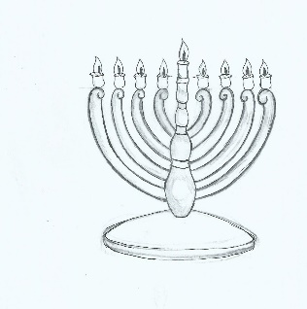

1. **What do you need to light a hanukiah?**
2. ……………………………………..
3. ……………………………………..
4. ……………………………………..
5. **Look at the new words below. Translate the words into Hebrew. Then fill in the sentences with the words.**

|  |  |
| --- | --- |
| English | Hebrew |
| 1. connect |  |
| 1. miracle |  |
| 1. way |  |
| 1. think |  |
| 1. speak |  |
| 1. do |  |

first- ראשית

we- אנחנו

then- אז

he- הוא

busy- עסוק

homework- ש"ב

work- לעבוד

wire- חוט

1. There was a …………… on Hanukah.
2. This is the ……………. to the yeshiva.
3. First we ………………, then we ………………………….
4. He is busy now, he is …………ing his homework.
5. It will work if you …………………. the wires.
6. **Now read and answer the questions on the side.**

above- למעלה

can- יכול

connect- לחבר\ לקשר

do- לעשות

example- דוגמה

flame- להבה

Jewish- יהודי

life- חיים

live- לחיות

miracle- נס

of- של

part- חלק

people- אנשים\ עם

speak- לדבר

think- לחשוב

through- בדרך

way- דרך

**The Parts of a Flame**

בראשית פרק מ פסוק י

ובגפן, שלושה שריגים; והיא כפורחת עלתה ניצה, הבשילו אשכלותיה ענבים.

(Adapted from בן איש חי שנה ראשונה פרשת וישב - הלכות חנוכה )

The Ben Ish Chai connects the words from the posuk above, "ובגפן שלושה שריגים", to the miracle of Hanukah. Gefen is the Jewish people and the **shlosha** sirigim are the three ways of living a life of Torah and mitzvot, through thinking, speaking and doing.

1. **a) What do the shlosha sirigm tell us?**

**b) Can you think of examples for each part?**

משלי פרק ו פסוק כג

called- נקרא

candle- נר

made up of- עשוי מ...

candleholder- פמוט

wick- פתיל

oil- שמן

without- בלי

these- אלו

light- אור

also- גם

different- שונה

color- צבע

so- אז

here- כאן

כי נר מצוה ותורה אור ודרך חיים תוכחות מוסר:

The Torah is called "ohr" and the mitzvot are called "ner". The candle is made up of three parts: the candleholder, the wick and the oil. Without one of these three parts, there is no flame and no light. The flame is also made up of three different colors. So here in the candle and in the flame there are the shlosha sirigim of thinking, speaking and doing.

**3) What are the three parts of the candle?**

**4) What are the three parts of the flame?**

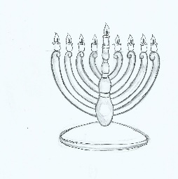



make (made)- לעשות

eight- שמונה

day- יום

miracle- נס

with- עם

That is why Hashem made an eight day miracle with the **menorah**. The Jews lived a life of Torah and mitzvot in their thinking, speaking and doing.

**5) Why did Hashem choose to make a miracle with the menorah?**

**Extra**

thought- מחשבה

speech- דיבור

action- מעשה

were saved- ניצלו

bad-רע

law-חוק

Greeks- יוונים

stop- להפסיק

celebrate- לחגוג

beat- לנצח

how- איך

letter- אות

also- גם

Aramaic- ארמית

again- שוב

Ben Ish Hai writes more about Hanukah. He says that because the Jewish people lived a life of Torah and mitzvot in thought, speech and action, they were saved from the three bad laws of the Greeks. The bad laws were to stop celebrating Shabbat, Rosh Hodesh and Brit Mila.

Also the zechut of Torah helped beat the bad laws. How? The Torah has five books, in Hebrew this is חמש. The letters of חמש are ח,מ,ש- which are for *hodesh (Rosh Hodesh), Mila and Shabbat* (חודש, מילה, שבת). Also the word "oil" in Aramaic is משח-, once again the letters of מ,ש,ח.

**6) How were the bad laws of the Greeks beat?**

(Adapted from בן איש חי שנה ראשונה פרשת וישב - הלכות חנוכה )

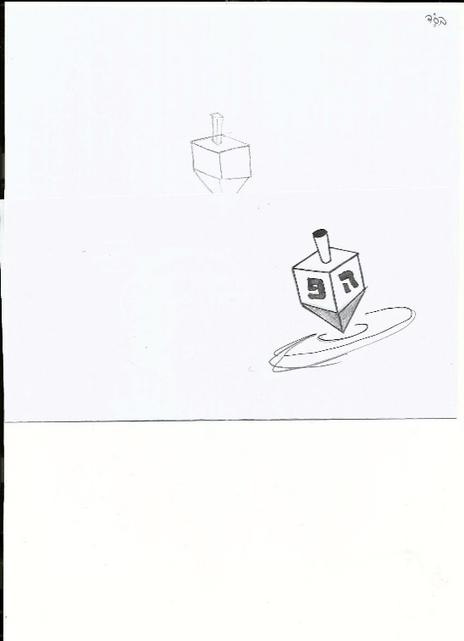

|  |  |  |
| --- | --- | --- |
| **New Word** | **Meaning** | **Your Practice Sentence** |
|  |  |  |
|  |  |  |
|  |  |  |
|  |  |  |
|  |  |  |
|  |  |  |
|  |  |  |
|  |  |  |
|  |  |  |
|  |  |  |
|  |  |  |
|  |  |  |
|  |  |  |
|  |  |  |
|  |  |  |
| **New Word** | **Meaning** | **Your Practice Sentence** |
|  |  |  |
|  |  |  |
|  |  |  |
|  |  |  |
|  |  |  |
|  |  |  |
|  |  |  |
|  |  |  |
|  |  |  |
|  |  |  |
|  |  |  |
|  |  |  |
|  |  |  |
|  |  |  |
|  |  |  |