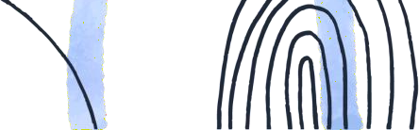



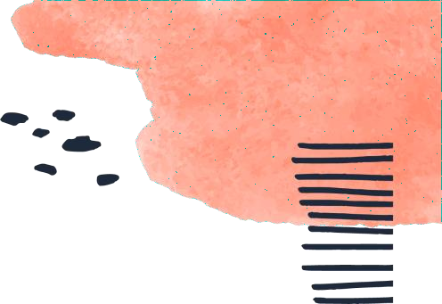



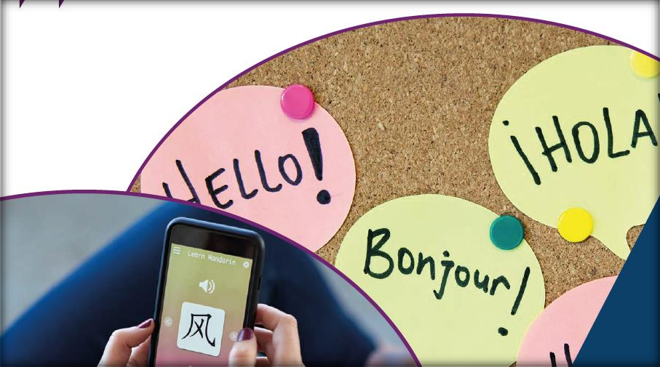
PISA 2025 Foreign Language Assessment Dr. Elias Farah January 2025


Governments are keen to know if their efforts to promote


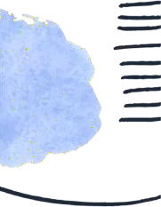
foreign language teaching and learning are effective. They would like to compare their students’ competencies in foreign languages with their own policy goals, international standards and other countries’ performance. Policy makers want to know how they can improve their students’ performance and learn about the most effective policies, and teaching approaches and methods from the countries that are most successful in providing young people with the foreign language skills they will need in the future.

OECD (2021), PISA 2025 Foreign Language Assessment Framework, PISA, OECD Publishing, Paris.

Objective – Summary

The Foreign Language Assessment (FLA) aims to inform and improve language teaching by providing:

- International comparisons
- National diagnostics
- Policy and practice lessons

Participating Countries
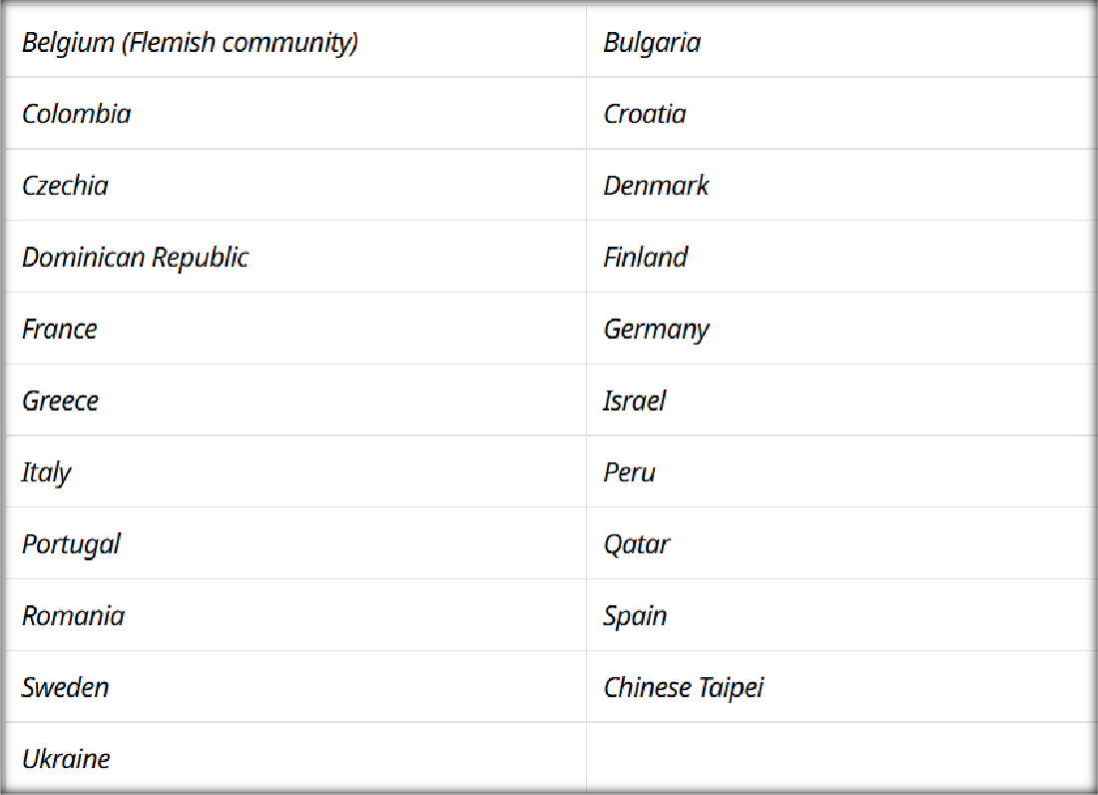

Definition of a Foreign Language
Foreign language proficiency is the ability to use a foreign language to communicate effectively. It requires a combination of communicative language competences and general competences that allow the foreign language learner to perform communicative language activities (reception, production,
interaction and mediation), which involve one or a combination of the following skills: reading, listening, speaking or writing. It also requires the activation of appropriate language strategies.

OECD (2021), PISA 2025 Foreign Language Assessment Framework, PISA, OECD Publishing, Paris, (P. 28).

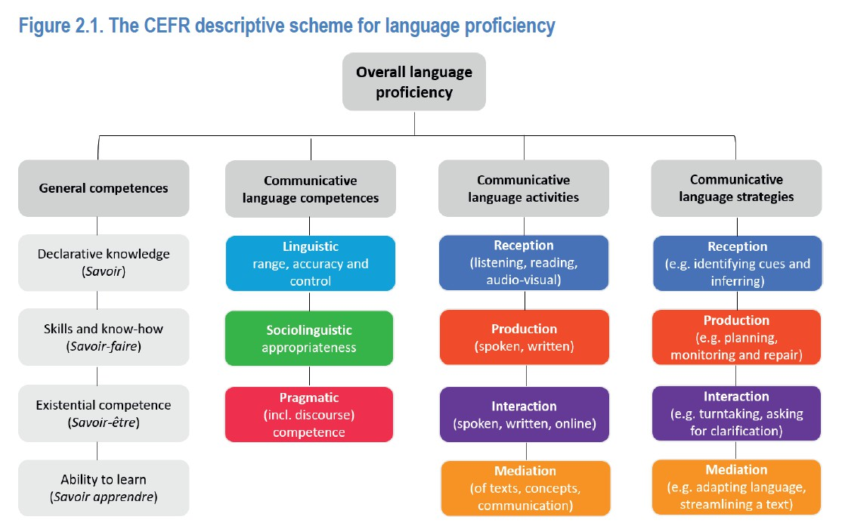

Why Teach a Foreign Language?

- It promotes intercultural understanding
- It provides economic opportunities
- It leads to cognitive benefits (creativity & critical
thinking)

“While teaching foreign languages in general is increasingly central in education policies, English has become the main foreign language being taught and learned.”

The Foreign Language Assessment (FLA) will be composed of:

  - A test to assess the foreign language proficiency of 15-year-old students

  - A set of questionnaire modules for teachers, students, and schools, as well as a system-level questionnaire to collect context and policy-relevant information

The PISA 2025 Foreign Language Assessment (FLA) will include key language competencies that are needed to study and work in a globalized world.

It will be organized by skill and the 2025 cycle will focus on reception (reading and listening comprehension) and production (speaking) only.

How will the test be built?
The test will be built on the Common European Framework of Reference for Languages (CEFR) levels, ranging from pre-A1 to C1, and the socio- cognitive model of language use based on Weir’s 2005 model of test development and validation.

OECD (2021), PISA 2025 Foreign Language Assessment Framework, PISA, OECD Publishing, Paris, (P. 24).

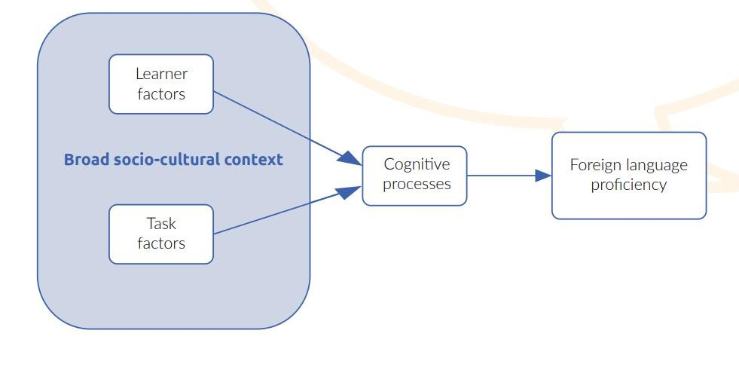
Factors that contribute to foreign language proficiency

OECD (2021), PISA 2025 Foreign Language Assessment Framework, PISA, OECD Publishing, Paris, (Brochure, P. 5).

Learner Factors:

To ensure that the test is fair, PISA will:

- Select texts that are appropriate to the age group and are not biased against a particular gender or country.

- Use background questionnaires that allow for the investigation of some of the learner factors expected to relate to proficiency (e.g. attitudes, motivation, etc.)

- Familiarise students with the test-navigation interface and the task types before having them complete the test.

Learner Factors:

To ensure that the test is fair, PISA will:

- Ensure that test instructions are accessible for all students, irrespective of their language ability. They will also contain visual cues.

- Ensure the listening and speaking tasks contain written and audio instructions.

Task Factors
- Variety of English

- Test forms: Reading and listening are adaptive while
speaking is not.

- Task forms: Each task will provide evidence of one or more “can-do” descriptors in the corresponding CEFR scale. The tasks will reflect the typical progression for language learners in school settings.

OECD (2021), PISA 2025 Foreign Language Assessment Framework, PISA,
OECD Publishing, Paris, (Brochure, P. 7).






Important!

  - The test takes up to two hours to complete.
  - There are no accommodations on the test.

The Questionnaires

The PISA FLA will include questionnaires for teachers, students and school principals. In addition, information will be collected on a system-level about teaching and learning of a foreign language.

Data collected through the questionnaires will be analyzed together with the results of the test to gain better insights on the factors that impact FL learning.

How will PISA report foreign language proficiency?

- Students’ proficiency will be reported using the CEFR scales (Pre-A1 to C1). Each skill tested (reading, listening, and speaking) will be reported separately.

- The results will be reported at the state level by PISA and at the sector level by Rama. Schools participating in the test will remain anonymous throughout the process.

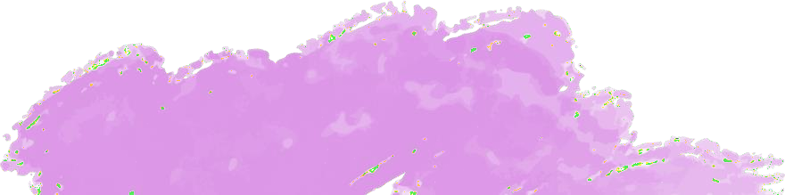



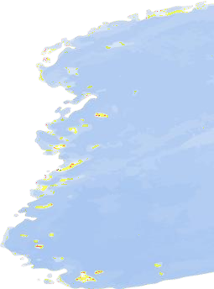

Sample Test Questions Reading

More information

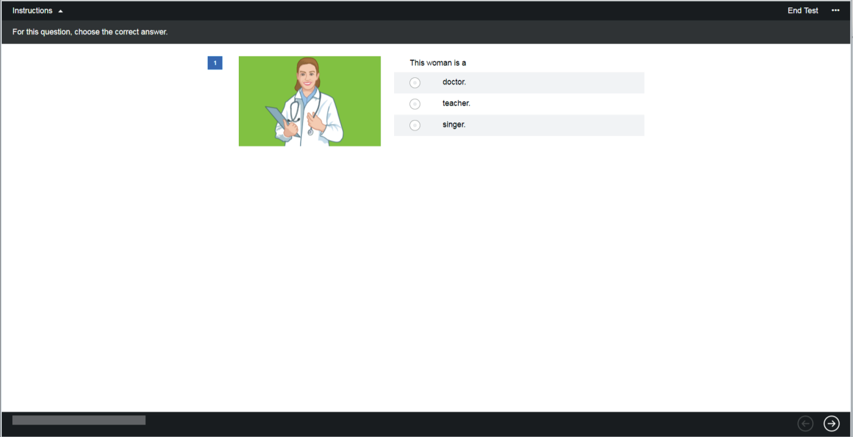

Discrete definition with graphic
Pre-A1

Cognitive Process: Word recognition and lexical access

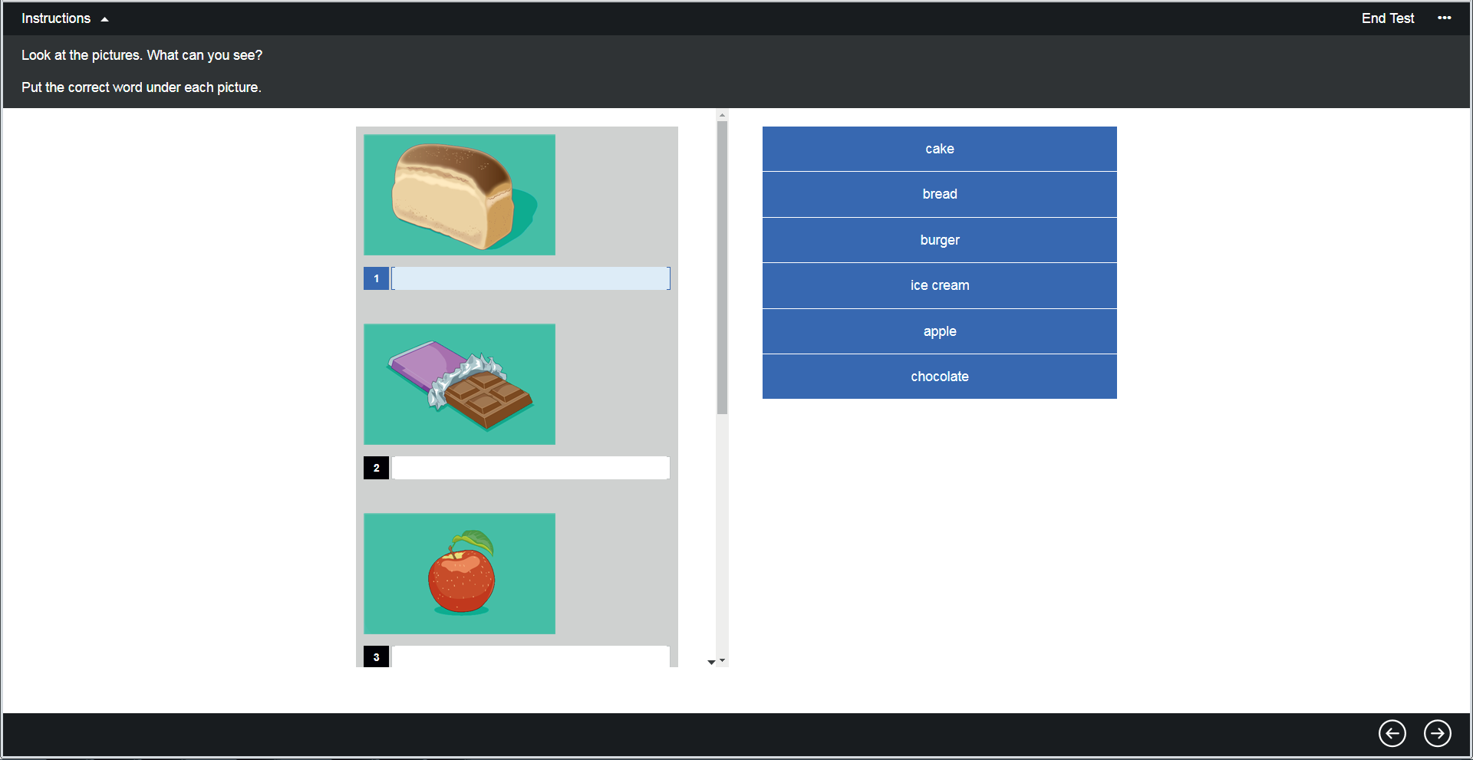

Matching picture and words
Pre-A1

Cognitive Process: Word recognition and lexical access

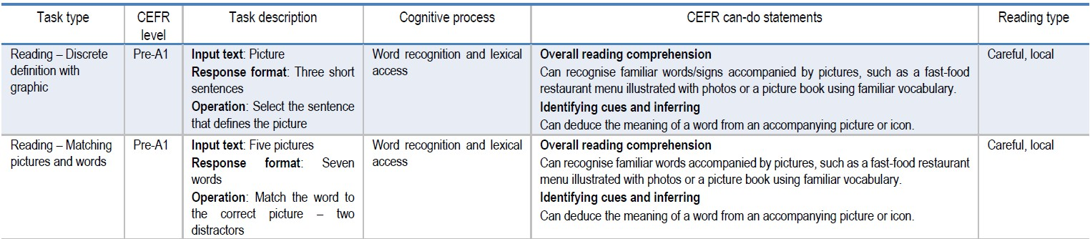

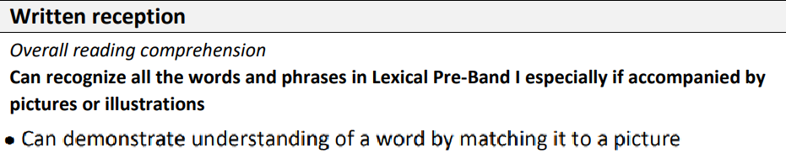
English Curriculum 2020

Lexical items tested in the two sample tasks:

Word | Band
doctor | I
teacher | I
singer | I
cake | I
bread | I
burger | II
ice cream | I
apple | I
chocolate | I

A1

Discrete gapped sentence A1
A2
Cognitive Process: Lexical access/ propositional meaning at sentence
level

words to select from

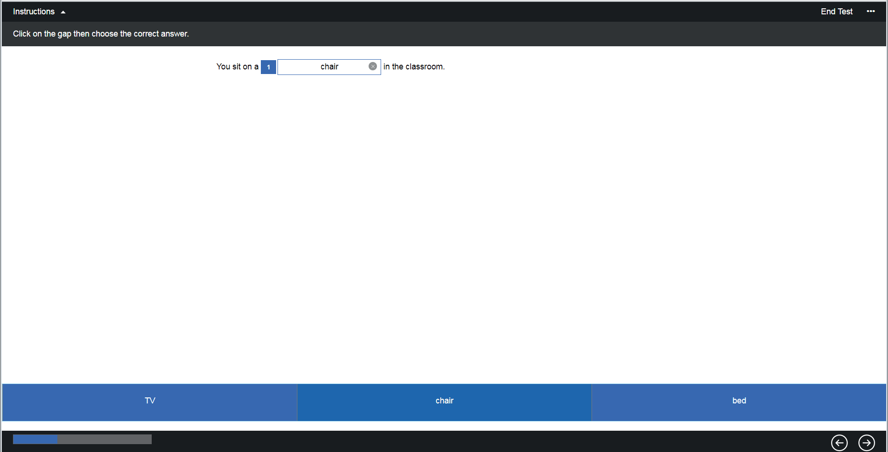

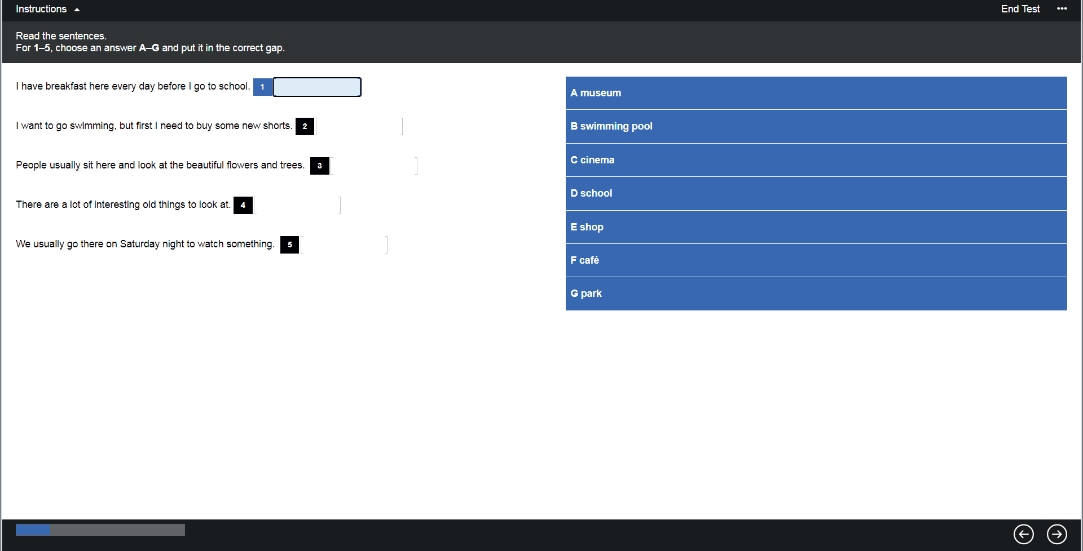

Matching sentences A1

Cognitive Process: Establishing propositional meaning at sentence level

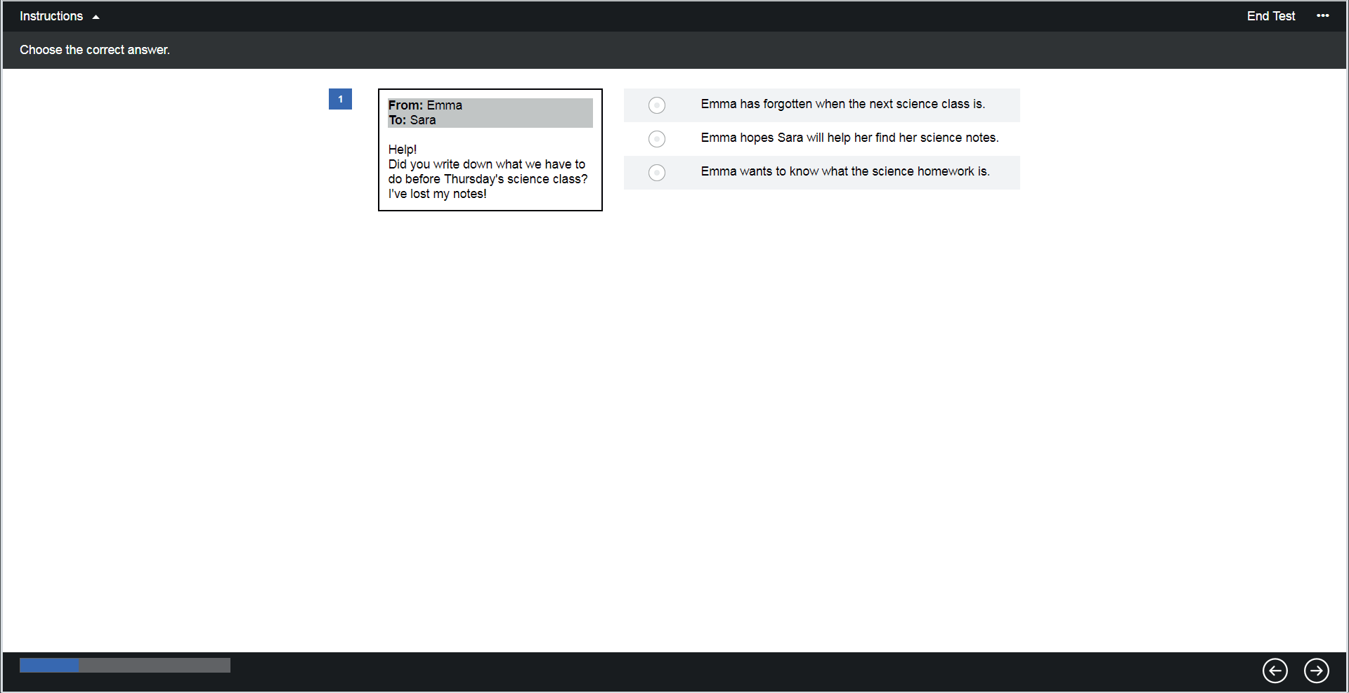

Discrete multiple- choice A1
A2
B1
Cognitive Process: Propositional meaning at sentence level

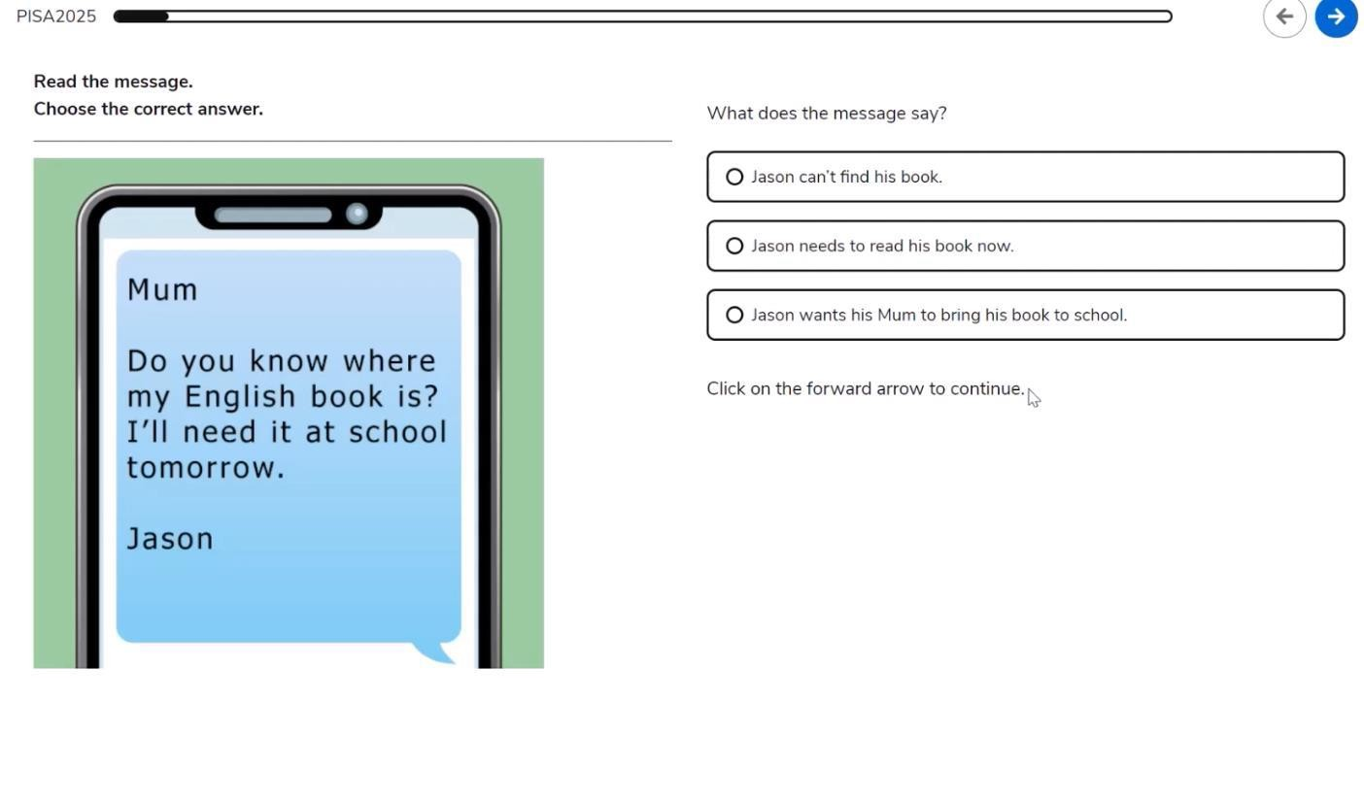

Simple multiple- choice A1
A2
B1
Cognitive Process: Propositional meaning at sentence level

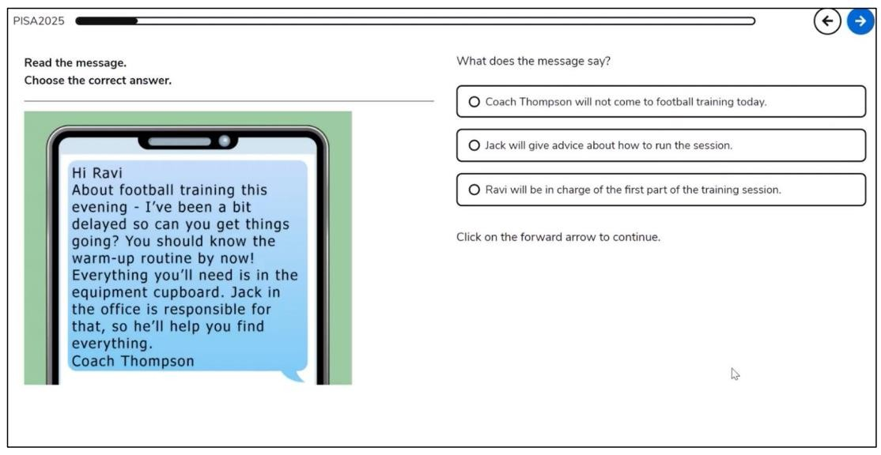
Simple multiple- choice A1
A2
B1
Cognitive Process: Propositional meaning at sentence level
Simple inferencing

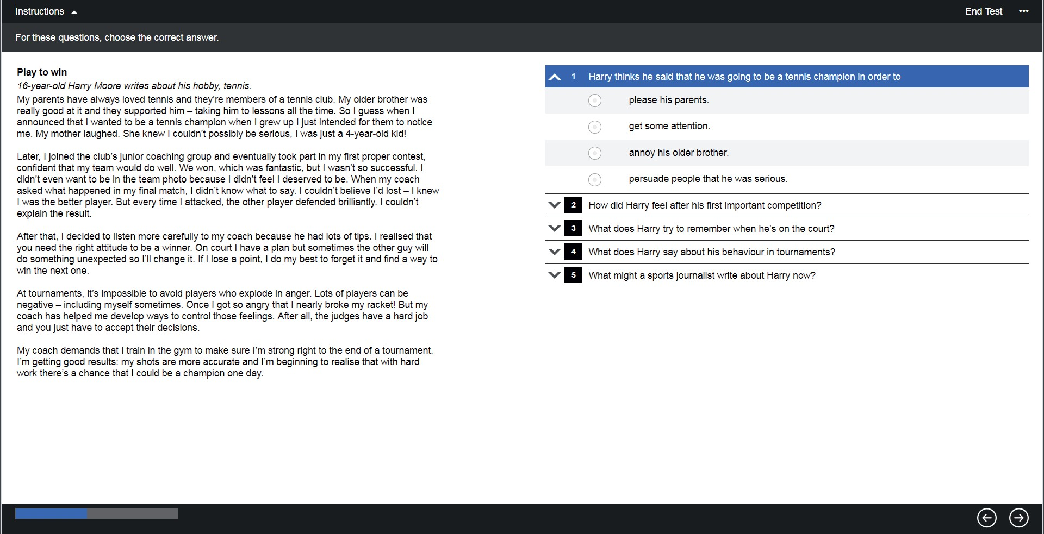

Multi-item, Multiple- choice
B1 B2 C1

Cognitive Process: Building a mental model

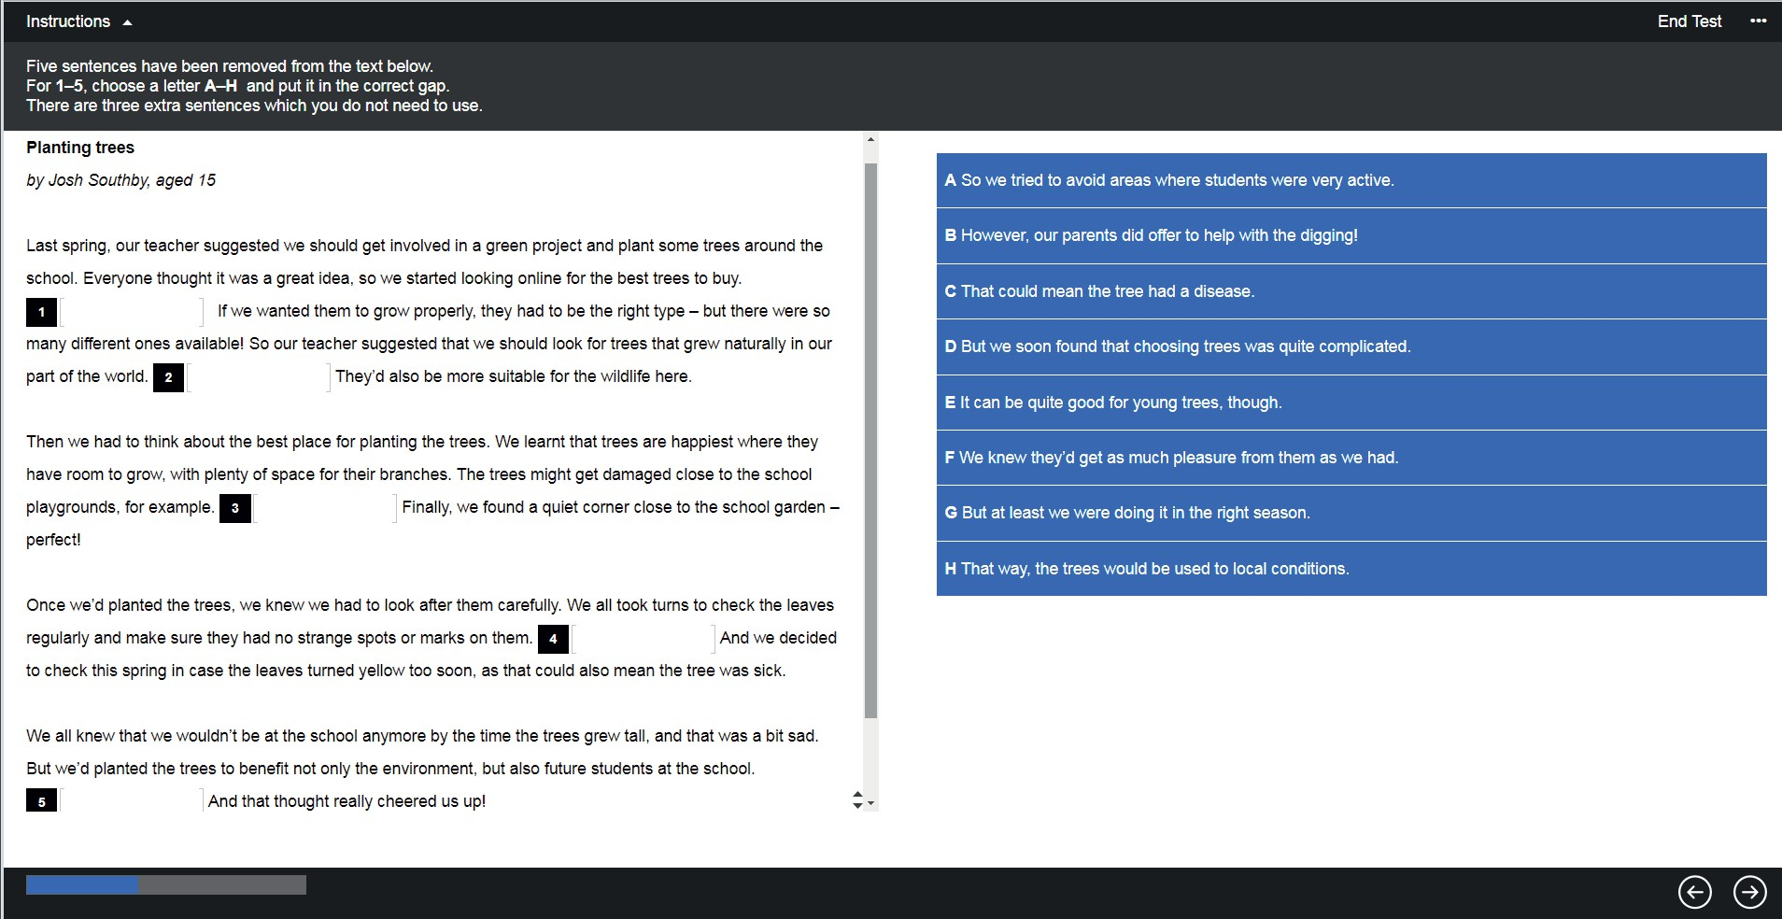

Matching gapped text - sentences B1

Cognitive Process: Building a mental model

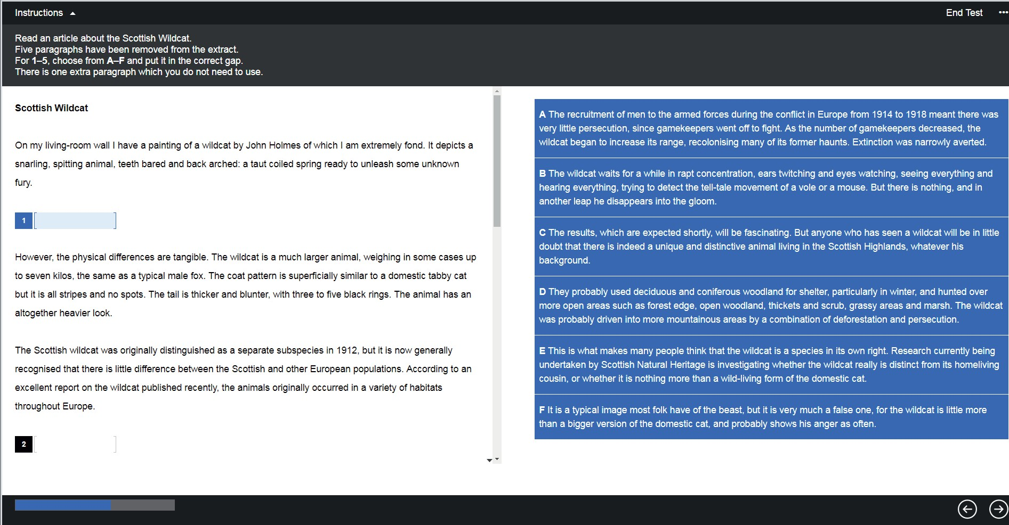

Matching gapped text paragraphs C1

Cognitive Process: Creating a text-level structure

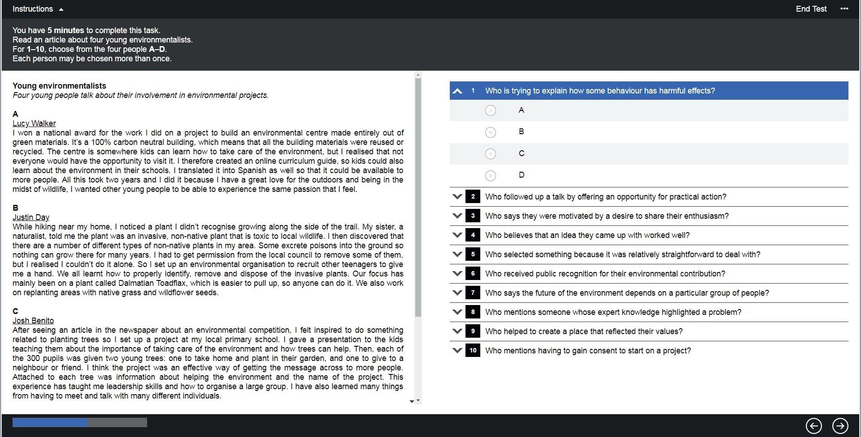

Cross-text matching B2

Cognitive Process:

Building a mental model

Sample Test Questions Listening

More information

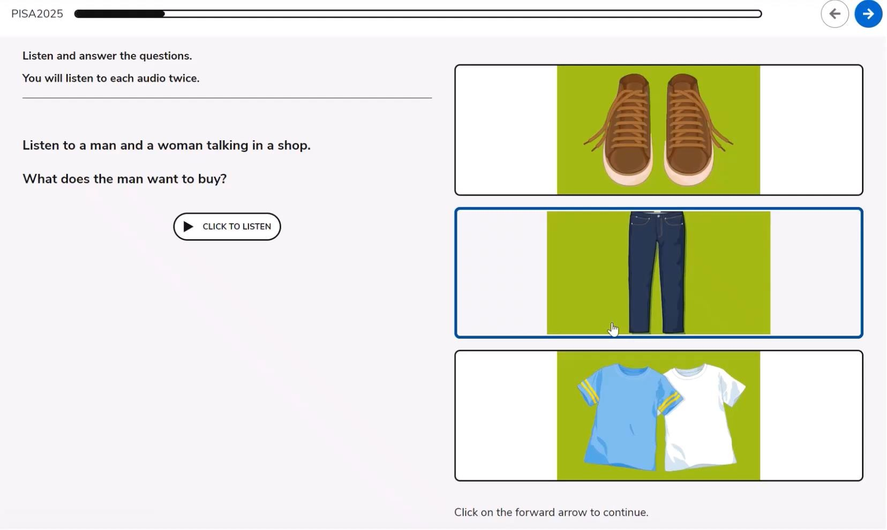

Discrete multiple choice with graphics Pre-
A1 A1 A2

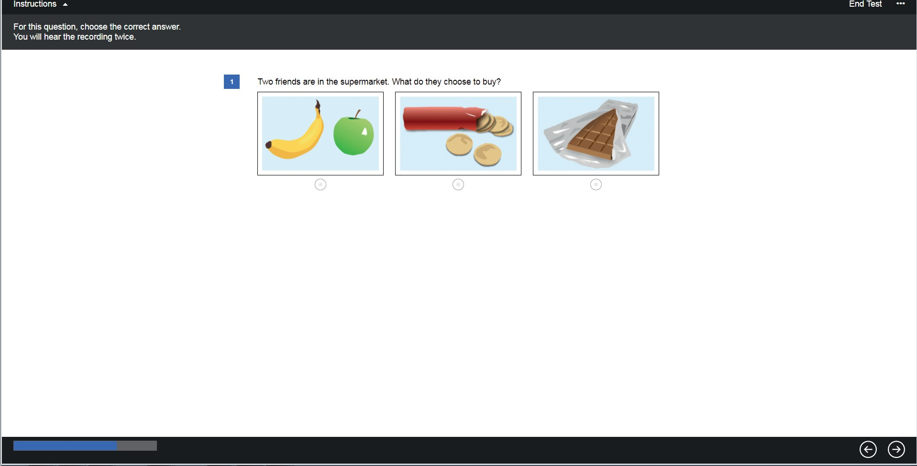

Discrete multiple choice with graphics Pre-
A1 A1 A2

Cognitive Process: Lexical search

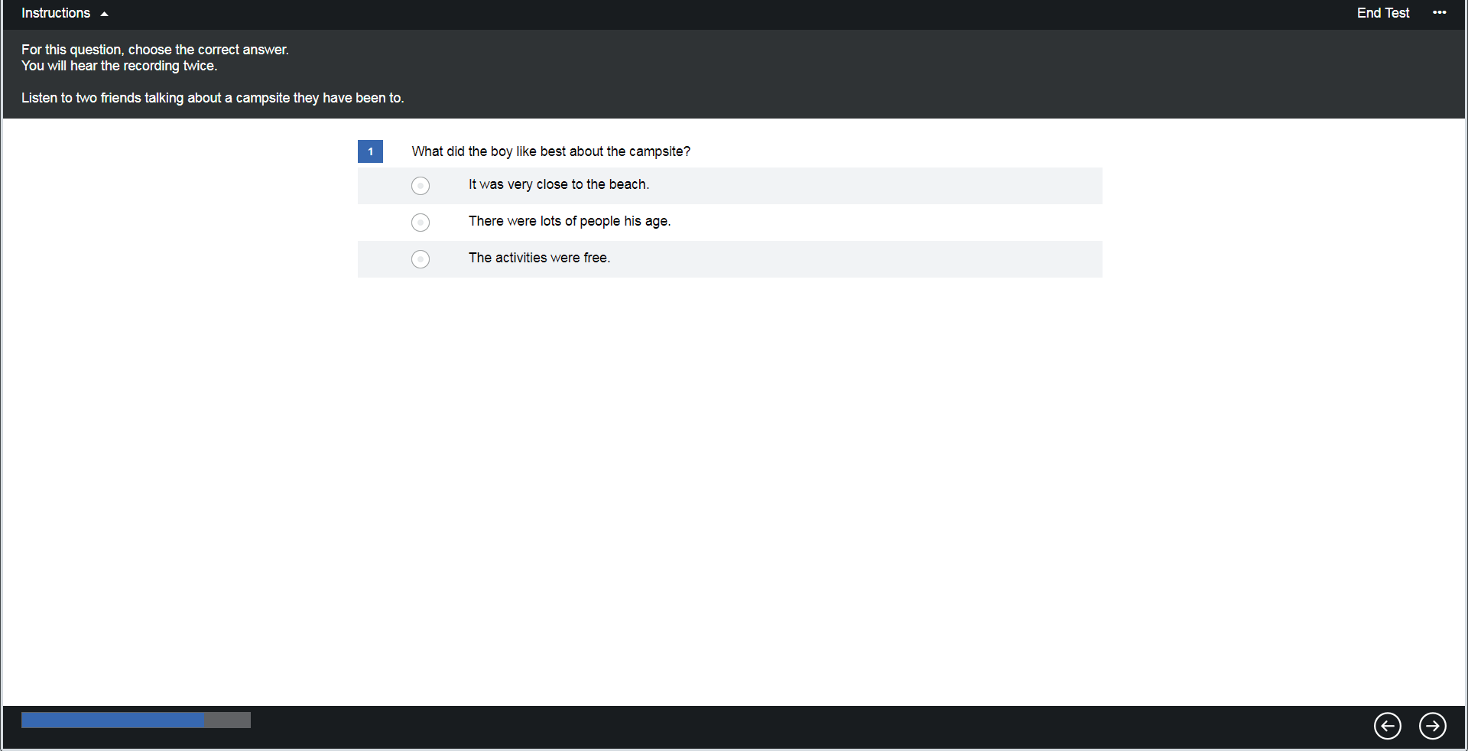
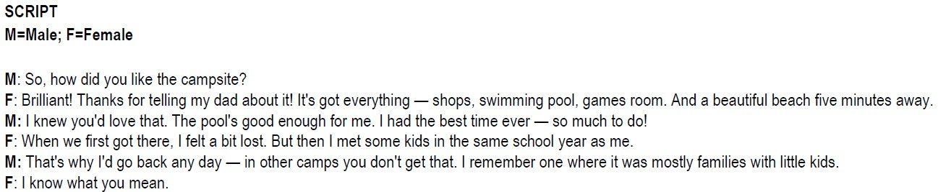

Discrete Multiple- choice with script B1
B2
C1
Cognitive Process:
B1 – Parsing
B2& C1 –
Meaning construction

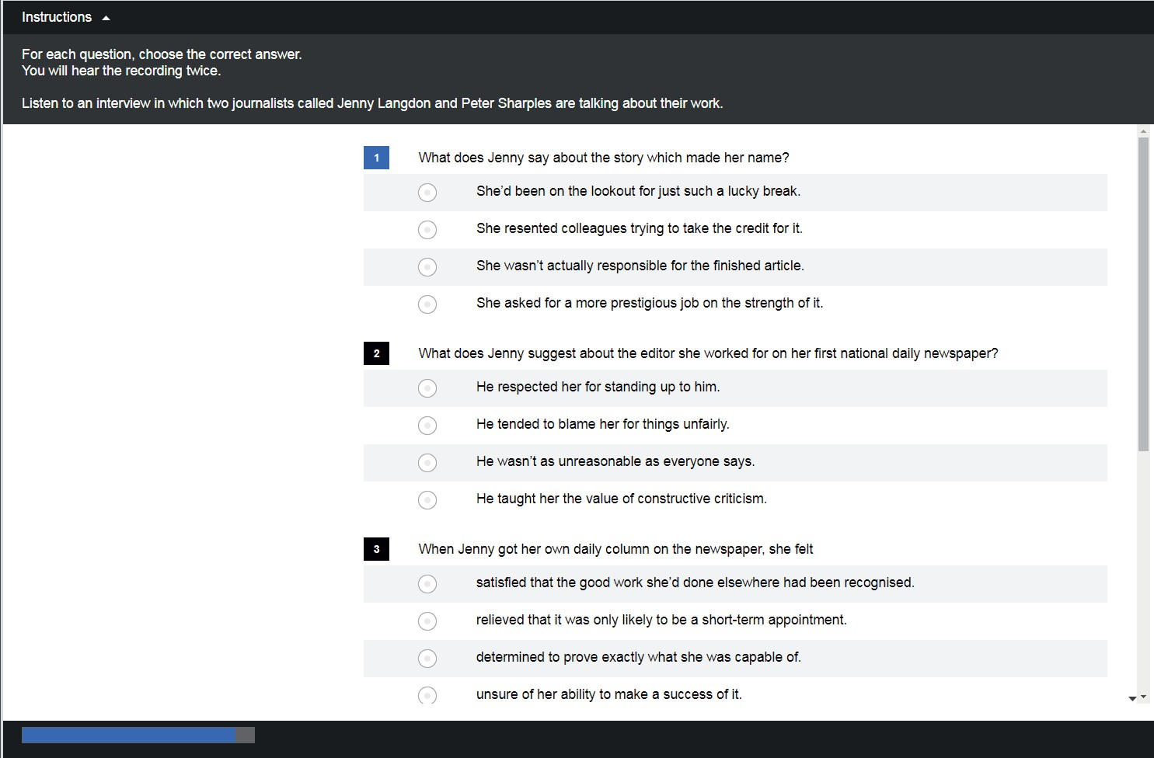


Multi-item Multiple choice B1
C1

Script is on page 116-117 click here:

Sample Test Questions
Speaking

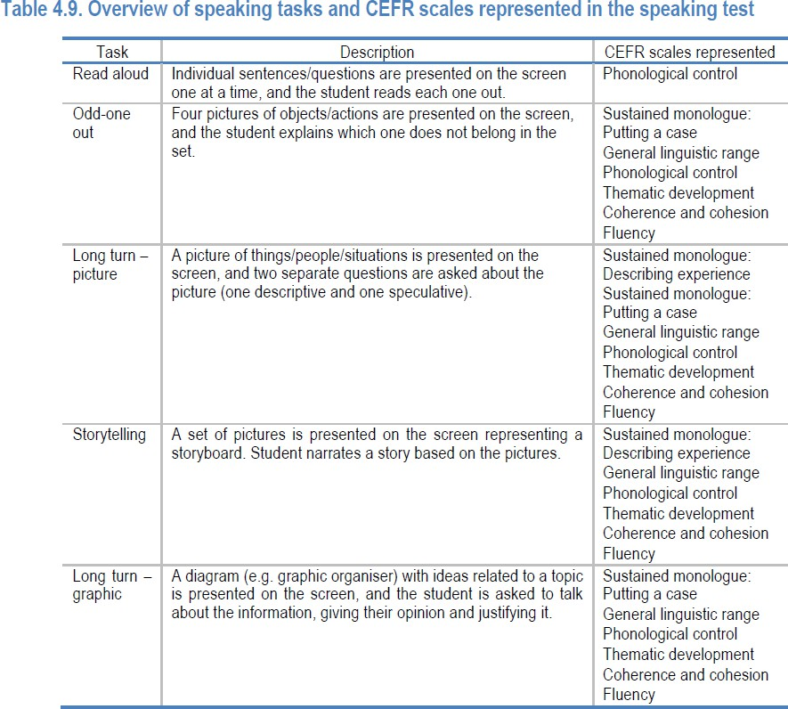

PART 1: READ ALOUD

You will see 5 sentences. You have 10 seconds to read each of them out loud. Please start reading out loud now.
For example:
“Essays must be handed in by the end of May”

PART 2: ODD-ONE-OUT
You will see a set of 4 pictures. One of them is different. First you have 5 seconds to look at the pictures. Please say which one is different, and why it is different. There are 4 sets of pictures.


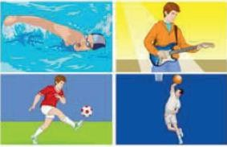

An alternative task can ask questions about daily activities and famous people!
View the next slide which contains a video
explaining the task.

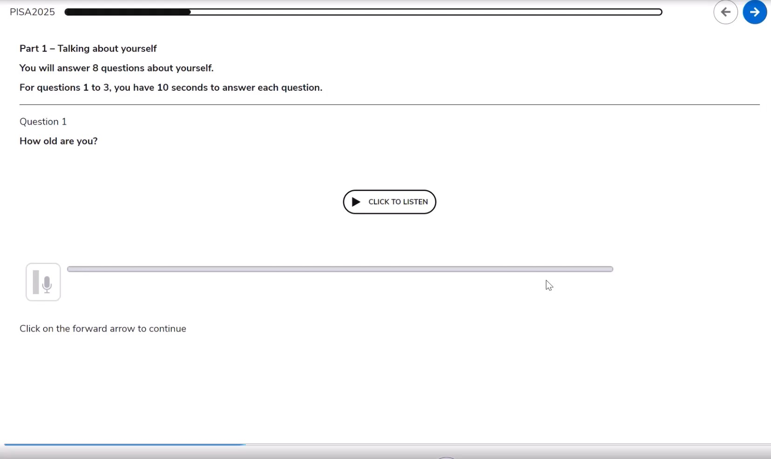

PART 3: TALKING ABOUT PHOTOGRAPHS
You will have to talk about a picture. First, you have 10 seconds to look at the picture. You will be asked 2 questions. You have 30 seconds for each question.
Question 1: What is happening in the picture?
Question 2: Why do you think the people are smiling?
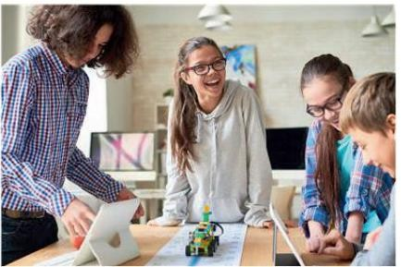

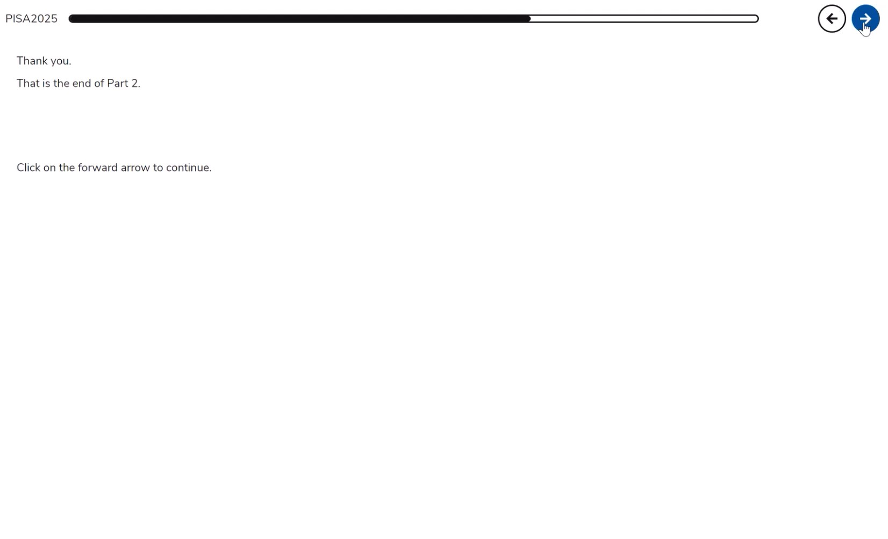

PART 4: TELLING A STORY
You will tell a story about 5 pictures and answer a question.
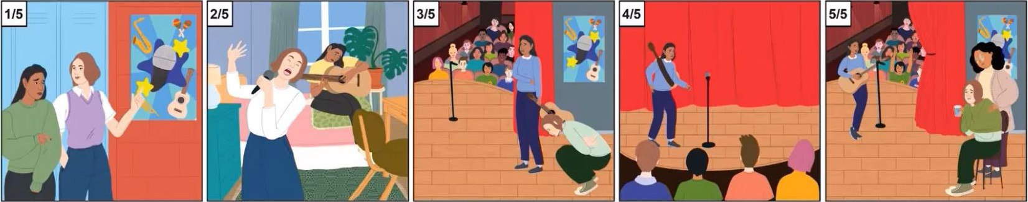
Here is the story. You will have 70 seconds to tell the story. First, you have 15 seconds to look at the pictures.

PART 4: TELLING A STORY (CONTINUED)
What advice would you give a friend who wants to be more confident?
You have 35 seconds to answer.

PART 5: LONG TERM
I’d like you to talk about learning English.
What are the best ways to learn English? Here are some ideas to help you.
You now have 1 minute to talk about what are the best ways to learn English and why.
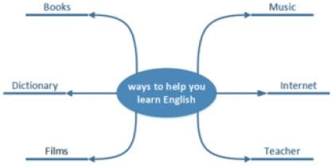

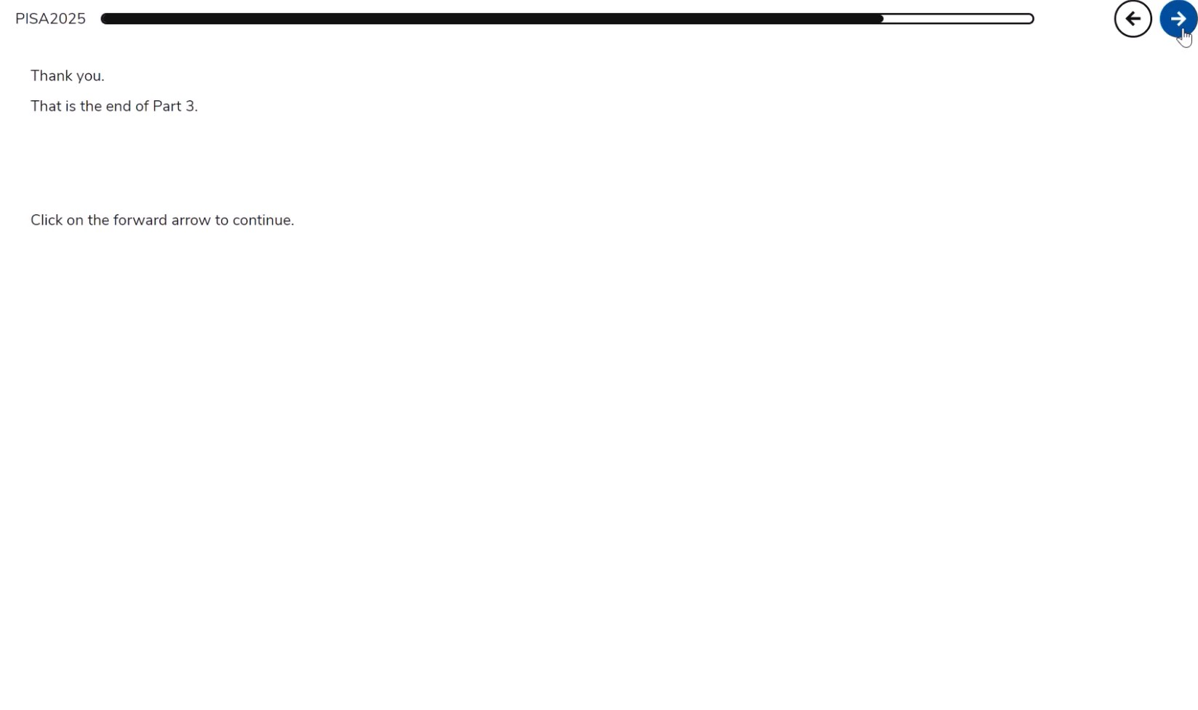




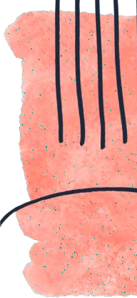
Relevant Links
(This PPT is based on these documents and quotes from them)


PISA 2025 Foreign Language Assessment Framework
01
The CEFR can-do statements and sample questions begin at p. 93.
The podcast is based on the booklet.
PISA 2025 Foreign Language Assessment Framework (Brochure)
02
PISA 2025 Foreign Language Assessment (General)


Click on “released items” for files with the recording.
03



PISA 2025 Released Field Trial Foreign Language Assessment (FLA) items
04



The brochure summarizes the booklet.
More sample questions (released in November).






The PISA Coordinator at your school can get in touch with RAMA if you have any inquiries!
Thank You!




