בס"ד

**Phrasal Verb Stories for Boys**

Phrasal verbs aren't the easiest thing to learn or teach. However, these expressions are an important part of our language and they need to be learned and reviewed.

One reason it's important to work with phrasal verbs is that there are so many of them, and their true meaning is different from their literal translation.

Another reason is that phrasal verbs can often have several meanings. If it wasn’t hard enough having to learn the difference between *get on, get along, get around, get into, get away, get over* and so on, then you discover that their meaning depends very much on the context.

At the end of the day, most of our learners will recognize the value of understanding phrasal verbs. This booklet provides a context for phrasal verbs. Each page has a story, dialogue or anecdote with five phrasal verbs. Why only five? Five is manageable. Five isn’t frightening. Five is *comfortable*.

The situations in this book are relevant to teenagers. The stories and dialogues are written in first person, which allows the students to put themselves into the place of the narrator.

On the following page, you will find suggestions on how to use the stories. Happy *Phrasaling*!

Phrasal Verb Stories by Michelle Worgan is licensed under a Creative Commons Attribution- ShareAlike 4.0 International License.

You can copy and adapt this work on the condition that you give attribution and inform of any changes made.

Acknowledgements by original author, Michelle Worgan

I would like to thank my students for motivating me to write these short stories. They needed to learn phrasal verbs and I needed a way of helping them, so I started giving them tests with five phrasal verbs per week. They sometimes complain about the length of the stories, as they copy them into their notebooks, but they realize that this has helped them learn over 40 phrasal verbs! Let’s hope they learn many more!

Thank you to the following users of morgueFile for allowing their photos to be used: [greyerbaby,](http://www.morguefile.com/creative/greyerbaby) [hotblack](http://www.morguefile.com/creative/hotblack), [pedrojperez](http://www.morguefile.com/creative/pedrojperez), [Seemann,](http://www.morguefile.com/creative/Seemann) [Dave](http://www.opticgroove.com.au/), [mzacha](http://www.morguefile.com/creative/mzacha), [Alvimann,](http://www.morguefile.com/creative/Alvimann) [jackietrains](http://www.morguefile.com/creative/jackietrains), [taylorschlades](http://www.morguefile.com/creative/taylorschlades), [tat](http://www.morguefile.com/creative/tat), [taliesin](http://www.morguefile.com/creative/taliesin)



Suggestions: How to use the stories

1. Give the students the original text. Ask them to find the phrasal verbs.

2. Ask them to work in pairs to say what they think each phrasal verb means, using the context to help them.

3. Provide a list of definitions or translations for them to match with each verb.

4. Read the text to the class. They listen and write down the phrasal verbs they hear. They then listen again and take notes. In pairs, students then work together to reconstruct the text.

5. Give the students the gapped text. Ask them to think about what information is missing. Then give them the five phrasal verbs with definitions and have them complete the text.

6. Use the gapped text as a vocabulary test. In the previous lesson, give students the five phrasal verbs to study. Give students the text to complete and stick in their notebooks.

7. In later lessons, review the phrasal verbs by showing the picture from one of the pages and asking the students if they can remember the story. Can they remember the phrasal verbs?

8. Have the students create a multiple-choice vocabulary exercise by writing sentences. They should delete the particle(s) from the phrasal verbs and insert a question mark. Below the text, they should add the particle, along with three distractors (alternative particles). They then swap and do their partner’s exercise.

For example:

We wanted to get ? but I couldn't find a babysitter.

1. on
2. **away**
3. in
4. over

9. Tech or no tech?

If you have an interactive whiteboard or projector, use it to project the relevant part of the page to the whole class.

If you don’t have any equipment, copy the text onto the board and have the students copy the whole text into their notebooks. Alternatively, you could dictate the text.

*Tip:* When checking whether students have used the phrasal verbs appropriately, make sure they have used the correct form. **Different tenses have been used throughout the stories**!

**Note to teachers in Israel:**

**The document has been adapted for use in Israeli schools, utilizing the ministry's word bands 1-3 and PHaVE (list of most frequent phrasal verbs).**

**For more about PHaVE:** <https://afa4be34-0fda-46d9-8e64-5adf13d4216b.filesusr.com/ugd/5f2482_6f61568a40834f168f9424e0cf7d4448.pdf>

**Some of the original texts have been changed or deleted. New texts have been added to accommodate other phrasal verbs not included in the original texts. The pictures were taken from Creative Commons and pixabay. We hope you'll find this helpful.**

**A Dream for the Future (Band 1)**

When I was **growing** **up**, I had many problems. However, I had a lot of help, and now my life is wonderful. Last week I decided that it's time to **give back.** I boughttwenty small presents and went to the children's home. I have volunteered there, so the children know me. When they saw me, they ran to me and asked what I have. I told them to **turn around** and not to look. Then I **gave out** the presents. The children were so happy! I gave presents, but I **got back** love.



When I was _____________, I had many problems. However, I had a lot of help, and now my life is wonderful. Last week I decided that it's time to _____________**.** I boughttwenty small presents and went to the children's home. I have volunteered there, so the children know me. When they saw me, they ran to me and asked what I have. I told them to _____________ and not to look. Then I _____________ the presents. The children were so happy! I gave presents, but I _____________ love.

**The Job (Bands 1 & 2)**

My father's friend lost his job last year but now he is **setting up** his own business. He is selling Judaica like *kippot* and *mezuzot*. He is **looking for** someone to **look after** the store when he is busy. I want a job so I will have money to buy my mom a birthday present. I have **filled in** an application form and for experience I wrote that I sold lemonade in the summer. I have to be careful that my mother shouldn't **find out** why I'm saving my money. I will be very disappointed if the surprise is ruined.



My father's friend lost his job last year but now he is __________________ his own business. He is selling Judaica like *kippot* and *mezuzot*. He is __________________ someone to __________________ the store when he is busy. I want a job so I will have money to buy my mom a birthday present. I have __________________ an application form and for experience I wrote that I sold lemonade in the summer. I have to be careful that my mother shouldn't__________________why I'm saving my money. I will be very disappointed if the surprise is ruined.

**My Little Brother (Bands 1 & 2)**

My two-year-old brother Yakov is cute and fun to be with, but sometimes he's TOO playful. He doesn't do what you tell him to do. If you **put** a sweater **on** him, he thinks it's funny to **take** it **off.** Oneday my mother took Yakov to the zoo. They **got on** the bus and went five stops. It was time to **get off**. But my brother likes riding on buses, and he didn't want to go to the zoo. He wanted to ride on the bus! He wouldn't **give in.** The bus driver drove to the next stop. My silly brother didn't go to the zoo that day.



My two-year-old brother Yakov is cute and fun to be with, but sometimes he's TOO playful. He doesn't do what you tell him to do. If you ___a sweater ___him, he thinks it's funny to _____ it ____**.** Oneday my mother took Yakov to the zoo. They _________the bus and went five stops. It was time to __________. But my brother likes riding on buses, and he didn't want to go to the zoo. He wanted to ride on the bus! He wouldn't __________.The bus driver drove to the next stop. My silly brother didn't go to the zoo that day.

**The Shopping Trip (Bands 1& 2)**

Last Sunday I went shopping with my brother. We **looked up** a few stores in the phone book, and then we went to a big shop where I wanted to buy a shirt. However, we couldn't **get in** because there were too many people there. Instead I **picked up** a nice shirt in a smaller shop and I went to try it on, but it was too small. I asked the shop assistant for a bigger size but he had to **sort out** other clothes so he wasn't helpful. I will still **go on** shopping there though, as the clothes are really nice.

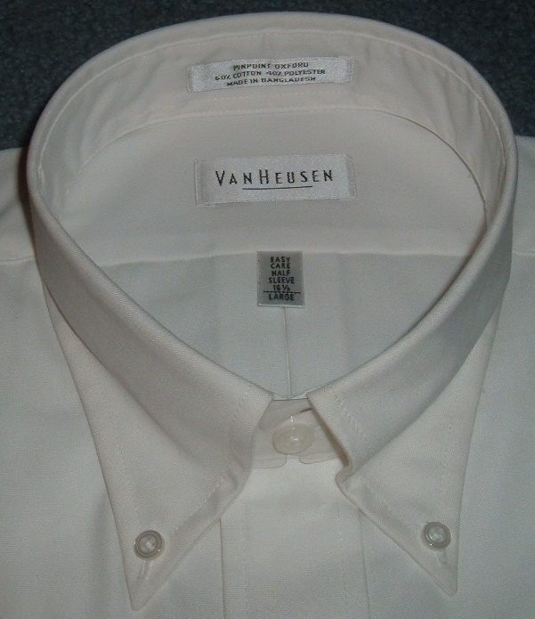

[תמונה זו](https://en.wiktionary.org/wiki/button-down) מאת מחבר לא ידוע ניתן ברשיון במסגרת [CC BY-SA](https://creativecommons.org/licenses/by-sa/3.0/)

Last Sunday I went shopping with my brother. We ____________a few stores in the phone book, and then we went to a big shop where I wanted to buy a shirt. However, we couldn't ____________because there were too many people there. Instead, I ______________a nice shirt in a smaller shop. I tried it on, but it was too small. I asked the shop assistant for a bigger size but he had to _____________other clothes so he wasn't helpful. I will still ____________ shopping there though, as the clothes are really nice.

**The Adventure (Bands 2 & 3)**

I had a little adventure recently. I had some problems at yeshiva and I found it really hard to **get through** all the learning I had to do. It was hard to tell my parents. I **got up** early in the morning, and **set out** to yeshiva, but didn't go into class. I walked around until I got tired and decided to rest on a bench. My rebbi **came up** to me and asked me if I was OK. He told me that I should be in class and said that if I didn't go in, I would disappoint my parents. I thought about what he said. When I went home, I **ended up** telling my parents about my problems with the learning and they arranged a meeting with my rebbi.

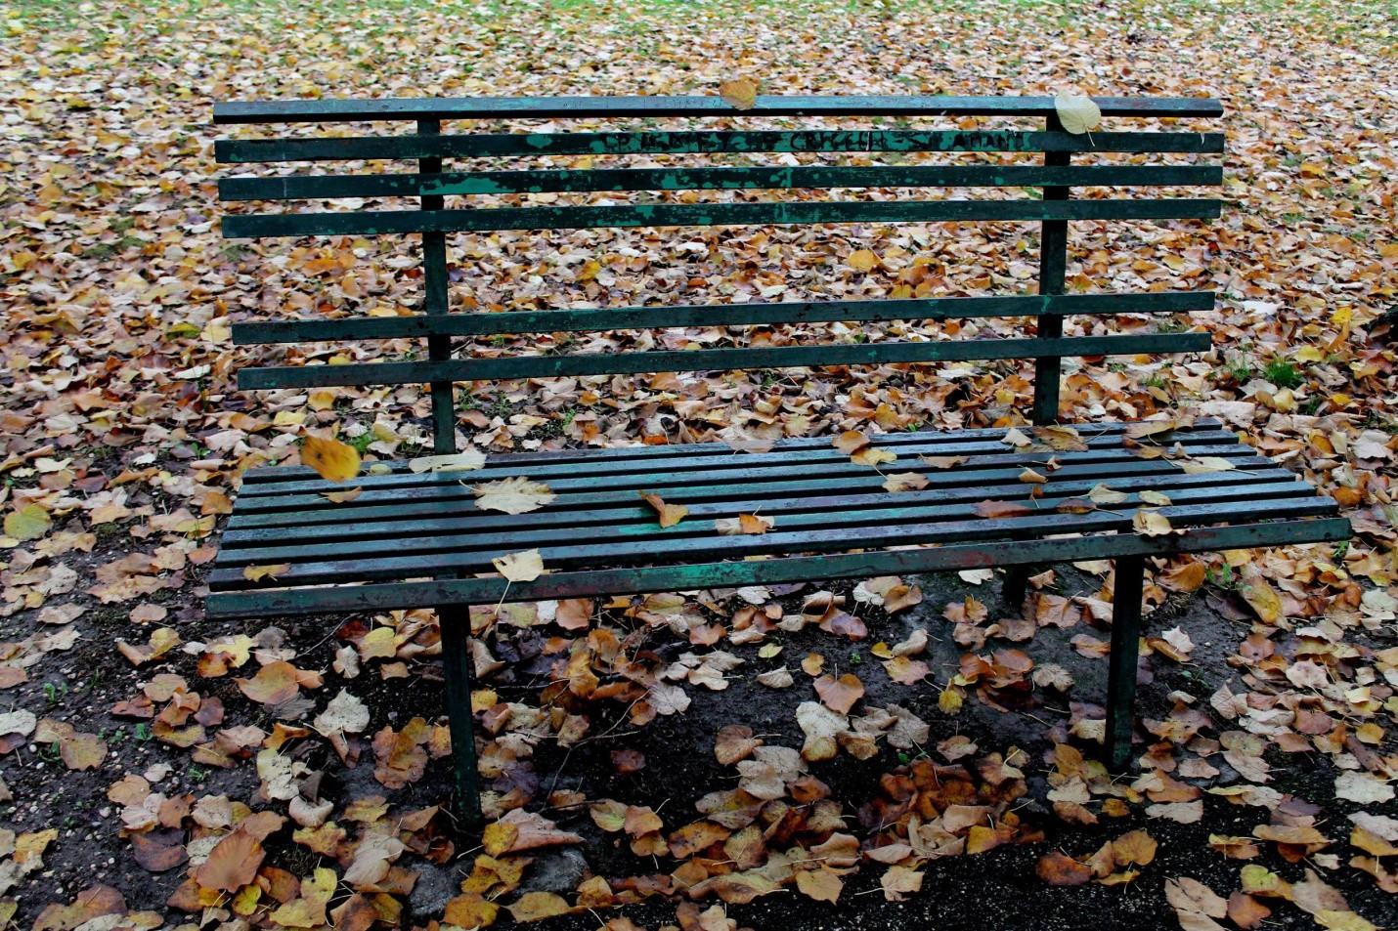

I had a little adventure recently. I had some problems at yeshiva and I found it really hard to ______________ all the learning I had to do. It was hard to tell my parents. I ______________ early in the morning, and ______________ to yeshiva, but didn't go into class. I walked around until I got tired and decided to rest on a bench. My rebbi ______________ to me and asked me if I was OK. He told me that I should be in class and said that if I didn't go in, I would disappoint my parents. I thought about what he said. When I went home, I ______________ telling my parents about my problems with the learning and they arranged a meeting with my rebbi.

**The Health Freak (Bands 2 & 3)**

My best friend **works out** a lot because he really cares about his health. He has stopped eating sugary foods and snacks like potato chips. I like exercising and he is trying to get me to train with him for an advanced class, but I think I'm **running out of** time. There are only a few weeks to go, but I won't **slow down** now! My friend agrees that I should **go ahead** with my plans even if I can't get in to the class. It's already **paying off**. I feel wonderful.



[תמונה זו](http://lyonsmasters.blogspot.com/2011/05/importance-of-exercise.html) מאת מחבר לא ידוע ניתן ברשיון במסגרת [CC BY-NC-ND](https://creativecommons.org/licenses/by-nc-nd/3.0/)



[תמונה זו](http://lyonsmasters.blogspot.com/2011/05/importance-of-exercise.html) מאת מחבר לא ידוע ניתן ברשיון במסגרת [CC BY-NC-ND](https://creativecommons.org/licenses/by-nc-nd/3.0/)

My best friend ________________ a lot because he really cares about his health. He has stopped eating sugary foods and snacks like potato chips. I like exercising and he is trying to get me to train with him for an advanced class, but I think I'm ________________ time. There are only a few weeks to go, but I won't ________________ now! My friend agrees that I should ________________ with my plans even if I can't get in to the class. It's already ________________. I feel wonderful.

**Friendship Problem (Bands 2 & 3)**

Dear Helpful Hananya,

I used to have a friend at school until one day he asked me to be his learning partner. I didn't think this would be a good idea, so I **turned** him **down**. The problem is that he wanted to work with me, but I preferred to learn alone. He **kept on** phoning me every night. The other guys told me to wait and that he would **give up** eventually, but I felt like I couldn't **put up with** it.

In the end**,** I **got away with** learning alone. But now I ask myself…..

Did Ido the wrong thing?

Yours, Anon

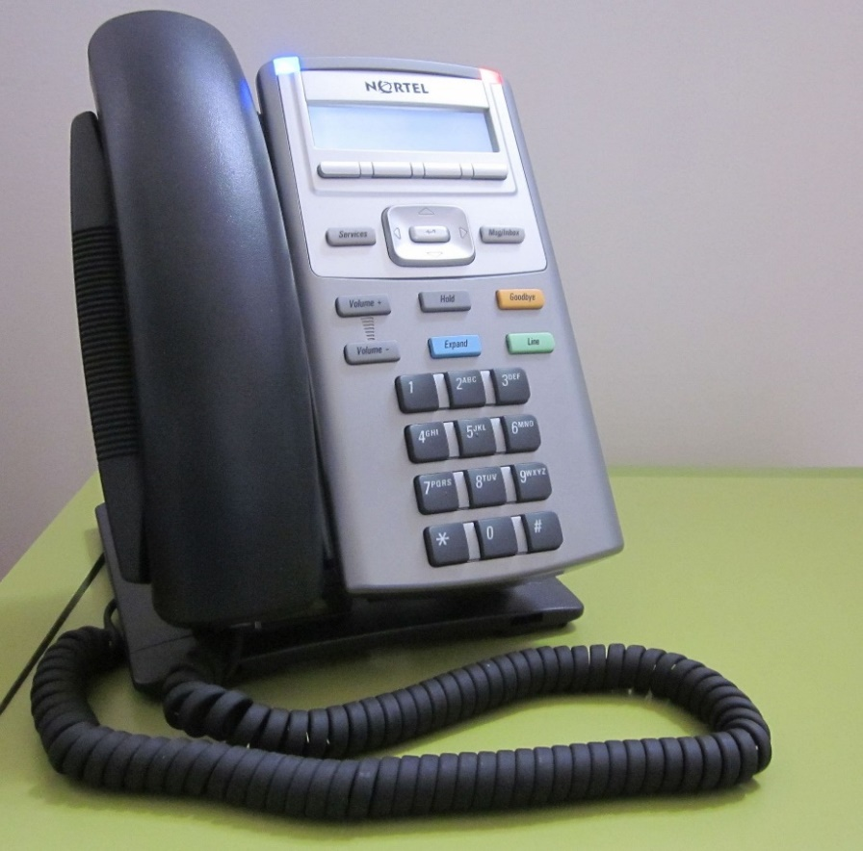

Dear Helpful Hananya,

I used to have a friend at school until one day he asked me to be his learning partner. I didn't think this would be a good idea, so I __________ him __________. The problem is that he wanted to work with me, but I preferred to learn alone. He ____________________ phoning me every night. The other guys told me to wait and that he would____________________ eventually, but I felt like I couldn't ____________________ it.

In the end**,** I __________________ learning alone. But now I ask myself…..

Did Ido the wrong thing?

Yours, Anon

**Jealousy (Band 3)**

Chaim: Hey, you need to help me **clean up** our room.

Moshe: Ok, **hang on** a minute. I'm just finishing my breakfast!

Chaim: Our aunt and uncle will be here soon.

Moshe: I know. I wonder if cousin Yisrael will have a new, expensive suit. He always has something new!

Chaim: Well, Uncle Yossi has worked very hard to earn his money. Did you know he's just **taken over** another company? As it **turned out**,Yisrael wastheir only child, so they gave him everything. Do you know how lonely he is? Are you still jealous?

Moshe: You're right. I **take** it **back.**

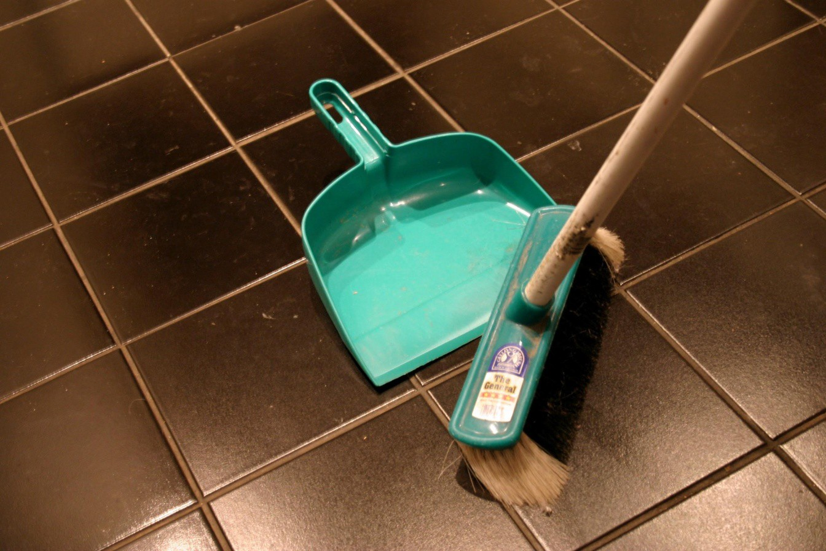

Chaim: Hey, you need to help me ___________ our room.

Moshe: Ok, ___________ a minute. I'm just finishing my breakfast!

Chaim: Our aunt and uncle will be here soon.

Moshe: I know. I wonder if cousin Yisrael will have a new, expensive suit. He always has something new!

Chaim: Well, Uncle Yossi has worked very hard to earn his money. Did you know he's just ___________ another company? As it ___________, Yisrael wastheir only child, so they gave him everything. Do you know how lonely he is? Are you still jealous?

Moshe: You're right. I _________it_______**.**

**Best Friends (Band 3)**

I called one of my oldest friends the other day. I really wanted to **catch up** with him to find out what was going on in his life. We hadn't spoken for a long time. We chatted for ages, and shared our problems. I told him that I was tired and I couldn't **figure out** why. He **pointed out** that I needed to take some time off for a break. He's right!

We agreed to take a walk together this morning, but he didn't **show up**! He just called to apologize. He explained that he had accidentally **turned off** his alarm clock, so he didn't get up in time.



I called one of my oldest friends the other day. I really wanted to ___________ with him to find out what was going on in his life. We hadn't spoken for a long time. We chatted for ages, and shared our problems. I told him that I was tired and I couldn't ___________ why. He ___________ that I needed to take some time off for a break. He's right!

We agreed to take a walk together this morning, but he didn't ___________! He just called to apologize. He explained that he had accidentally ___________ his alarm clock, so he didn't get up in time.

**List of Phrasal Verbs in Alphabetical Order**

|  |  |  |  |  |
| --- | --- | --- | --- | --- |
|  | Phrasal Verb | Page Number | Position on PHaVE | Band |
| 1. | Catch up | 11 | 53 | 3 |
| 2. | Clean up | 10 | 65 | 3 |
| 3. | Come up | 7 | 4 | 3 |
| 4. | End up | 7 | 18 | 3* |
| 5. | Figure out | 11 | 21 | 3* |
| 6. | Fill in | 4 | 141 | 1 |
| 7. | Find out | 4 | 6 | 1 |
| 8. | Get away with | 9 | - | 3 |
| 9. | Get back | 3 | 19 | 1 |
| 10. | Get in | 6 | 98 | 1 |
| 11. | Get off | 5 | 56 | 2 |
| 12. | Get on | 5 | 127 | 2 |
| 13. | Get through | 7 | 117 | 3 |
| 14. | Get up | 7 | 23 | 2 |
| 15. | Give back | 3 | 128 | 1 |
| 16. | Give in | 5 | 143 | 1 |
| 17. | Give out | 3 | 142 | 1 |
| 18. | Give up | 9 | 16 | 2 |
| 19. | Go ahead | 8 | 32 | 2 |
| 20. | Go on | 6 | 1 | 1 |
| 21. | Grow up | 3 | 10 | 1 |
| 22. | Hang on | 10 | 83 | 3 |
| 23. | Keep on | 9 | 102 | 3* |
| 24. | Look after | 4 | - | 2 |
| 25. | Look for | 4 | - | 2 |
| 26. | Look up | 6 | 20 | 2 |
| 27. | Pay off | 8 | 78 | 3 |
| 28. | Pick up | 6 | 2 | 1 |
| 29. | Point out | 11 | 9 | 3 |
| 30. | Put on | 5 | 87 | 1 |
| 31. | Put up with | 9 | - | 3 |
| 32. | Run out | 8 | 103 | 3 |
| 33. | Set out | 7 | 64 | 3* |
| 34. | Set up | 4 | 11 | 2 |
| 35. | Show up | 11 | 27 | 3 |
| 36. | Slow down | 8 | 68 | 3 |
| 37. | Sort out | 6 | 136 | 2 |
| 38. | Take back | 10 | 72 | 3 |
| 39. | Take off | 5 | 28 | 1 |
| 40. | Take over | 10 | 37 | 3* |
| 41. | Turn around | 3 | 40 | 1 |
| 42. | Turn down | 9 | 94 | 3 |
| 43. | Turn off | 11 | 106 | 1 |
| 44. | Turn out | 10 | 12 | 3 |
| 45. | Work out | 8 | 29 | 3 |

Notes about the bands: This list was prepared after band 1 was updated.

In addition, words from band 3 with a star (*) are from the shortened list of 400 words.