ASK

Charedi Kit for
Teaching and Assessing Speaking

Adapted from the ASK Kit

Contents
Introduction to the Assessing Speaking Kit (ASK Kit) 4
Unit 1 - Asking and Answering Simple Questions 6
Activity 1 - Birthdays 6
Activity 2 - Eating Habits 6
Activity 3 - Hobbies/Free Time Activities 7
Activity 4 - Living in Israel 7
Activity 5 - About Names 7
Activity 6 - Personal Feelings 8
Activity 7 - School 8
Activity 8 - Learning about Each Other 8
Instructional Activity Jeopardy 9
Instructional Activity Onion 10
For the Teacher — Checklist for Grading 11
Rubric for the Student (with Hebrew if necessary) 11
Unit 2 - Expressing Personal Wishes and Opinions 12
Activity 1 - 12
Activity 2 – 12
Activity 3 – 13
Activity 4 – 13
For the Teacher — Checklist for Grading 13
Rubric for the Student (with Hebrew if necessary) 14
Unit 3 - Giving Instructions, Complimenting and Giving Advice 15
Task A 15
Task B 15
Task C 15
Task D 15
Task E 15
Task F 16
Task G 16
Task H 16
Task I 16
Task J 17
Rubric for the Student (with Hebrew if necessary) 17
Rubric for the Student (with Hebrew) 18
Task 1 18
Task 2 18
Task 3 18
All 3 Tasks 18
For the Teacher — Checklist for Grading 18
For the Teacher — Checklist for Grading 19
Unit 4 - Engaging in Extended Conversations 19
List of Suggested Conversation Topics: 19
Instructional Activity Just a Minute 20
Rubric for the Student (with Hebrew if necessary) 21
Rubric for the Student (with Hebrew) 22
For the Teacher — Checklist for Grading 22
For the Teacher — Checklist for Grading 22
Unit 5 - Presenting Information Taken from Different Sources 23
Presentation 1 - A Country 23
Presentation 2 - A Person You Admire 23
Presentation 3 - A School Trip 24
Presentation 4 - How does Your Class Rate in "Chessed"? 24
Rubric for the Student (with Hebrew if necessary) 25
For the Teacher — Checklist for Grading 26
For the Student – Peer Assessment Form………………………………………………….27
Instructional Activity Trivia Hunt 28

Introduction to the Assessing Speaking Kit (ASK Kit)

What is the ASK Kit?
The ASK Kit was originally designed to assess students' speaking abilities. However, it's an excellent tool for teaching.
It is full of activities to promote and practice speaking individually, in pairs and in groups.
Who is the ASK Kit good for?
Originally, it was meant to be used in 7-9th grades, but it can be used at all levels.
The activities begin at an elementary level and gradually become more difficult. There are five levels of difficulty.
What is in the ASK Kit?
There are different types of activities; some are in the form of dialogues, some are games; there are also presentations.
These activities can be used both in class and at home, for practice as well as for testing students' proficiency.
May teachers make changes?
Absolutely! The kit was created with the intention of allowing teachers to use it for their classroom needs as they see fit.

How do I know what to do?
A teacher can use any number of activities in any order taking into account the level of difficulty and student interest. Each activity can be done independent of other activities. They are self-explanatory. (Where necessary, there are instructions.) The teacher can adapt it any way that will work in the specific classroom it will be used in. The activities include clear and specific rubrics and checklists which can be used as guidelines so the teacher and the students know what is expected. Of course, the rubrics can also be changed or adapted as necessary.
Not every activity needs to be assessed, but the rubrics can be used for assessment.

Assessing Speaking Kit

Unit 1 - Asking and Answering

Simple Questions

Activity 1 - Birthdays
Where were you born?
When is your birthday?
What do you like to do on your birthday?
How did you celebrate your birthday last year? Who did you celebrate with?
Where did you celebrate?
Tell me about a favorite birthday present you got. What was it? Who gave it to you?
Do you buy birthday presents for your friends/family? How do you choose a gift?

Activity 2 - Eating Habits
When do you eat your main meal during the week/on holidays?
Do you eat with your family? When? Describe a family meal.
What are your favorite foods?
Do you like cooking? If you do, what kind of food do you know how to prepare? Where did you learn how to make it?
Who taught you how to cook?
How often do you cook?
Who prepares the food you bring to school?
What do you like to eat at school?
What is the most important meal of the day?
What are healthy foods? Do you eat healthy food or do you prefer junk food?
Some people only eat junk food. What do you think about this?
Why do you think it is important to eat healthy foods? How would you encourage people to eat healthy foods?

Activity 3 - Hobbies/Free Time Activities
What kind of activities do you do in your free time?
What hobby/hobbies do you have? Please describe your hobby.
When did you get started with this hobby?
How did you choose it? How did it develop?
Where do you do this hobby?
How much time do you spend on this hobby?
What do your friends think about your hobby?
What are some of the things you like to do with your friends in your free time?
What do you usually do after school during the week?
What do you like best about Shabbat?
Do you have time to help at home? When you help, in what ways do you help?

Activity 4 - Living in Israel
Where do you live?
Describe the area you live in. What do you like about where you live?
Describe a place you have visited in Israel. Why did you visit this place?
What did you do there? Who did you travel with?
Do you go on trips to different places in Israel?
What is your favorite place in Israel and why?
Would you like to travel abroad? Which country would you like to visit?
Have you been abroad? Where? Describe your visit/trip.

Activity 5 - About Names
Do you like your name? Explain your answer.
Do you know why you were given your name?
Does your name have a special meaning?
Are you named after someone? What information do you know about her life/family/job/residence…?
Do you have a nickname? What is it? Why do people call you this? Who gave you your nickname? Do you prefer to be called by your name or by your nickname?
How do parents choose names for their children?
What names would you like to give to your children?

Activity 6 - Personal Feelings
What makes you feel happy? What makes you sad?
What makes you laugh? What makes you angry?
Describe a happy moment in your life.
Describe a funny moment in your life.
What is something that you are proud of?
Who do you admire and why?

Activity 7 - School
Which school did you go to before you started this school? Did you like it? Why?
What do you like best about school?
What subjects do you like best? Which do you find difficult to study?
What do you think are good subjects to learn for your future and why?
What activity at school has been the most fun this year and why?
What do you like about your school?

Activity 8 - Learning about Each Other
You are going to learn about each other by asking and answering
questions. The task involves four parts. Read each part carefully and follow the instructions.
Part 1 – Student A and Student B
Decide who will be Student A and who will be Student B.
Part 2 – Choice of Topic
Student A: Choose two topics from the list (your teacher will give
you the list of topics).
Student B: Choose two different topics from the list.
Part 3 – Preparation
Take a minute or two to think of questions related to your topic.
Part 4 – Asking and Answering Questions
Student A: Ask Student B questions about the topic you chose.
Student B: Answer the questions.
Student B: Ask Student A questions about the topic you chose.
Student A: Answer the questions.

 | Instructional Activity
Instructional Activity | "Jeopardy"
Objective | Asking and answering questions
Number of Participants | Whole class frontally
Time Allocation | Approximately 15 minutes (at least)
Procedure | Choose a topic and prepare a list of answers to different questions related to that topic.  Organize the questions into 3 levels of difficulty: easy, average, difficult.  Allocate points to the questions according to the level of difficulty as follows:  Easy questions 100 points  Average questions 300 points  Difficult questions 500 points  Draw this chart on the board:  Where it says topic, write topic names (food, music, e.g.)  Divide students into three groups.  One representative from each group participates in each round.  The student has to choose a topic and tell you what point value she is going for. For example, the student can choose "Food" with a 300 point value. You erase the 300 and write "vegetables". The student has to produce a logically correct question (What type of food grows on the ground?) for her team to get the point value for that question. The team with the most points wins the game.
  Topic | Topic | Topic
  500 | 500 | 500
  300 | 300 | 300
  100 | 100 | 100
Material(s) | Whiteboard and marker.  Alternatively, the teacher can make a chart with removable cards. It could have flaps with the point values on it which would be lifted to reveal the subtopic on the cards.  Another possibility is making a game with Power Point.
Feedback | Provide feedback that is particularly related to wh question formulation.

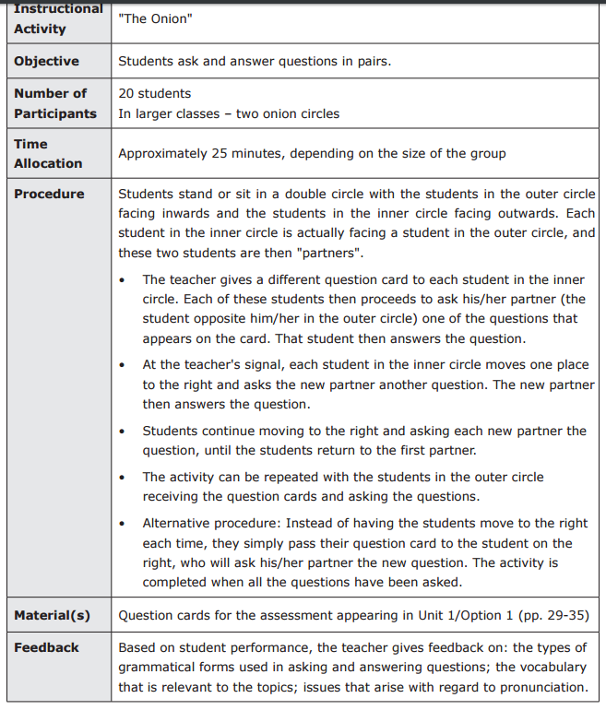

For the Teacher — Checklist for Grading

Criterion | Description | Level of Performance*
Communicative  Ability | Answers were clear and addressed the questions that were asked.  All the questions were answered. | 4 | 3 | 2 | 1
Fluency | Speech flowed smoothly | 4 | 3 | 2 | 1
Pronunciation | Speech was intelligible. | 4 | 3 | 2 | 1
Vocabulary | The words and chunks chosen were appropriate and conveyed meaning clearly. | 4 | 3 | 2 | 1
Language | The grammar was mostly appropriate and correct. | 4 | 3 | 2 | 1
* 4 = greatly 3 = very much 2 = to some extent 1 = hardly at all

Rubric for the Student (with Hebrew if necessary)
Criterion | Remember | זכרו | קריטריון
Communicative  Ability | Make your ideas clear.  Make sure the listener  understands your  meaning.  Match your response to what you were asked or to what you heard.  You may correct  yourself as you speak, or repeat what you said in different words. | מסרו את רעיונותיכם באופן ברור. וודאו שבן השיח מבין  את כוונותיכם.  התאימו את תגובותיכם לְמה  שנשאלתם או למה ששמעתם.  ניתן לעשות תיקון עצמי תוך כדי דיבור, או ניתן לחזור במילים אחרות. | יכולת תקשורתית
Fluency | Pay attention to how smoothly you speak.  In other words, speak without hesitations and without long stops. | שימו לב לדיבור רציף. במילים אחרות, דברו ללא היסוס וללא עצירות ממושכות. | שטף דיבור
Pronunciation | You should pronounce the words correctly and pay attention to the stress patterns of the words. Your main aim is to make sure your listener understands what you are saying. | הקפידו על הגייה נכונה של המילים ושימו לב לדגשים  בתוך המילים. המטרה המרכזית היא שבן השיח יבין את מה שאתם אומרים. | הגייה
Language | Pay attention to  word order, verb  tenses, subject–verb agreement. | שימו לב לסדר המילים, זמנים  של פעלים, התאמת נושא– פועל. | דקדוק
Vocabulary | Choose your words  carefully. Make sure the words are appropriate or suited to your goals and to the context, and use a variety of words. | בחרו את המילים באופן זהיר. וודאו שהמילים מתאימות למטרותיכם ולהקשר, והשתמשו במגוון מילים. | אוצר מילים

Unit 2 - Expressing personal wishes and opinions

Activity 1 -
What do you think about special needs students learning in regular schools/classes?
Do you know any special needs kids? If so, how did you get to know them?
Do you or did you ever study with a special-needs student? If so, what problems did the special needs student have? How did she feel? How did the other students feel?
How do you feel about special needs students learning in your school? What might be difficult for these students? What can we do about it?

Activity 2 –
Student Committee Decides how to Spend 500 Shekels
Your school had a cake sale and made 500 shekels. You are on the school committee. Choose a role. Take turns telling each other what you would like to do with the money to help your school and why. Respond to what you like and don't like about the other committee members' ideas and why. Reach a shared decision.
Roles:
• A student who wants to give the money to a student in need.
• A student who wants to use the money to buy books for the school library.
• A student who thinks the money should be spent on a class trip.

Activity 3 –
Your family is going on a trip
Your family is going on a trip in Tevet. Your parents asked your opinion about where you want to go, where you will sleep, and what activities there will be. Choose a role.
Take turns in telling each other where you want to go, where you want to sleep, and what you want to do on the trip. Respond to the ideas of your family members and make suggestions.
Roles:
• One brother wants a hiking trip with extreme sports.
• One sister likes to visit historical sites and famous places.
• An older sister doesn't like hiking and camping.
Activity 4 –
Planning a Surprise Party for a Friend
You want to have a surprise party for your friend. Choose a role. Decide where you want it, plan a program, and decide on the refreshments and a gift. Respond to the ideas of your friends.
Roles:
• One friend suggests a singing contest in school and thinks a gift is unnecessary.
• One friend suggests ordering pizza at home and buying a big gift.

For the Teacher — Checklist for Grading
Criterion | Description | Level of Performance*
Communicative  Ability | Wishes and opinions were conveyed clearly.  Answers were clear and matched the questions that were asked. | 4 | 3 | 2 | 1
Fluency | Speech flowed smoothly | 4 | 3 | 2 | 1
Pronunciation | Speech was intelligible. | 4 | 3 | 2 | 1
Vocabulary | The words and chunks chosen were appropriate and conveyed meaning clearly. | 4 | 3 | 2 | 1
Language | The grammar was mostly appropriate and correct. | 4 | 3 | 2 | 1

* 4 = greatly 3 = very much 2 = to some extent 1 = hardly at all

Rubric for the Student (with Hebrew if necessary)
Criterion | Remember | זכרו | קריטריון
Communicative  Ability | Make your wishes and  opinions clear.  Make sure the support  you give matches your  wishes and opinions.  You may correct  yourself as you speak,  or repeat what you said in different words. | הבהירו את הרצונות ואת הדעות שלכם.  וודאו שהתמיכה שאתם נותנים אכן מתאימה לרצונותיכם ודעותיכם.  ניתן לעשות תיקון עצמי תוך כדי דיבור, או ניתן לחזור  במילים אחרות. | יכולת תקשורתית
Fluency | Pay attention to how smoothly you speak.  In other words, speak without hesitations and without long stops. | שימו לב לדיבור רציף. במילים אחרות, דברו ללא היסוס וללא עצירות ממושכות. | שטף דיבור
Pronunciation | You should pronounce the words correctly and pay attention to the stress patterns of the words. Your main aim is to make sure your listener understands what you are saying. | הקפידו על הגייה נכונה של המילים ושימו לב לדגשים  בתוך המילים. המטרה המרכזית היא שבן השיח יבין את מה שאתם אומרים. | הגייה
Language | Pay attention to  word order, verb  tenses, subject–verb agreement. | שימו לב לסדר המילים, זמנים  של פעלים, התאמת נושא– פועל. | דקדוק
Vocabulary | Choose your words  carefully. Make sure the words are appropriate or suited to your goals and to the context, and use a variety of words. | בחרו את המילים באופן זהיר. וודאו שהמילים מתאימות למטרותיכם ולהקשר, והשתמשו במגוון מילים. | אוצר מילים

Unit 3 - Giving Instructions, Complimenting,
and Giving Advice

Task A
Tell me how to make a tuna sandwich/fruit salad/milkshake/smoothie.
Explain how to make it.

Task B
Explain how to play your favorite game.

Task C
Your partner is wearing a beautiful sweater/new shoes.
Student A: Tell her that you like it/them and explain why. When your
partner gives you more information, ask her more questions.
Student B: Reply by giving your partner more information about the
sweater/shoes: where you got it/them, why you like it/them.

Task D
Your partner made brownies and brought them to school.
Student A: Tell her how good they are and explain what you like
about them. When your partner gives you more information, ask her more questions.
Student B: Reply by giving your partner more information about the
brownies: where you got the recipe, how long it took to make them, what's in them (for example: sugar, chocolate, nuts).

Task E
Your partner just made a poster about road safety/keeping the school clean.
Student A: Tell her that you like it and explain why. When your
partner gives you more information, ask her more questions.
Student B: Reply by giving your partner more information about the
poster: why you made it, where it's going to be displayed, how long it took you to make it, why you are happy with it.

Task F
Your partner decorated the classroom bulletin board.
Student A: Tell her that you like it and explain why. When your
partner gives you more information, ask her more questions.
Student B: Reply by giving your partner more information about the
bulletin board: why you decorated it, what's going to be displayed on it and for how long, how long it took you to make it, why you are happy with it.

Task G
Your partner got a great new school bag.
Student A: Tell her that you like it and explain why. When your
partner gives you more information, ask her more questions.
Student B: Reply by giving your partner more information about the
school bag: where you got it, why you like it, why it's such a good bag, what’s special about the bag.

Task H
Student A: You want to stick to a healthy diet but don't know how. Ask your friend if she can help you learn how to eat healthy food.
Remember to ask for explanations and for more information after your friend speaks.
Student B: Give your friend some advice about how to eat healthy food. Remember to ask as many questions as you need in order to be able to give the best advice.

Task I
Student A: You would like to improve your grades. Ask your friend for advice about how to get better grades.
Remember to ask for explanations and for more information after your friend speaks.
Student B: Offer your friend some advice about how to improve her
grades. Remember to ask as many questions as you need in order to be able to give the best advice.

Task J
Student A: Your room is a mess and you can't find anything. Ask your friend to give you some ideas about how to organize it.
Remember to ask for explanations and for more information after your friend speaks.
Student B: Give your friend some advice about how to organize her
room so that she will always be able to find whatever she is looking
for.
Remember to ask as many questions as you need in order to be able to give the best advice.

Rubric for the Student (with Hebrew if necessary)
Criterion | Remember | זכרו | קריטריון
Communica-  tive  Ability | Task 1  Make your instructions clear.  Cover all important details when giving instructions.  Task 2  Make sure the information you give is clear.  Task 3  When requesting advice or giving advice, make sure your request or the  advice you give is clear.  All 3 Tasks  You may correct yourself as you speak, or repeat what you said in different words. | 1. הבהירו את ההוראות שלכם.  הקיפו את כל הפרטים  החשובים כאשר אתם נותנים הוראות.  2. וודאו שהמידע שאתם מוסרים הינו ברור.  3. כאשר מבקשים עצה או נותנים עצה, וודאו שהבקשה או הייעוץ שאתם נותנים ברור.  -------------------------  ניתן לעשות תיקון עצמי תוך כדי דיבור, או ניתן לחזור במילים אחרות. | יכולת  תקשורתית
Fluency | Pay attention to how smoothly you speak. In other words, speak without hesitations and without long stops. | שימו לב לדיבור רציף. במילים אחרות, דברו ללא היסוס וללא עצירות ממושכות. | שטף דיבור
Pronuncia-  tion | You should pronounce the words correctly and pay attention to the stress patterns of the words. Your main aim is to make sure your listener understands what you are saying. | הקפידו על הגייה נכונה של המילים ושימו לב לדגשים  בתוך המילים. המטרה המרכזית היא שבן השיח יבין את מה שאתם אומרים. | הגייה
Language | Pay attention to word order, verb tenses, subject–verb agreement. | שימו לב לסדר המילים, זמנים של פעלים, התאמת נושא– פועל. | דקדוק
Vocabulary | Choose your words carefully. Make sure the words are appropriate or suited to your goals and to the context, and use a variety of words. | בחרו את המילים באופן זהיר. וודאו שהמילים מתאימות למטרותיכם ולהקשר, והשתמשו במגוון מילים | אוצר מילים

Rubric for the Student (with Hebrew)
The rubric is the same except for "Communicative Ability".

Task 1
Make your instructions clear.
Cover all important details when giving instructions.

Task 2
Make sure the information you give is clear.

Task 3
When requesting advice or giving advice, make sure your request or the
advice you give is clear.

All 3 Tasks
You may correct yourself as you speak, or repeat what you said in different words.

For the Teacher — Checklist for Grading

Criterion | Description | Level of Performance*
Communicative  Ability | Task 1  Instructions were clear.  Instructions were comprehensive.  Task 2  The information was clear.  Task 3  The request for advice was clear.  The advice was clear. | 4 | 3 | 2 | 1
Fluency | Speech flowed smoothly | 4 | 3 | 2 | 1
Pronunciation | Speech was intelligible. | 4 | 3 | 2 | 1
Vocabulary | The words and chunks chosen were appropriate and conveyed meaning clearly. | 4 | 3 | 2 | 1
Language | The grammar was mostly appropriate and correct. | 4 | 3 | 2 | 1

* 4 = greatly 3 = very much 2 = to some extent 1 = hardly at all

For the Teacher — Checklist for Grading
The rubric is the same except for "Communicative Ability."
Task 1
Instructions were clear.
Instructions were comprehensive.
Task 2
The information was clear.
Task 3
The request for advice was clear.
The advice was clear.

Unit 4 - Engaging in Extended Conversations

List of Suggested Conversation Topics:
- Talk about/Describe a special gift you got in detail. Describe the gift and the
occasion and why it is special.
- Talk about/Describe a place that you visited in Israel in detail and why you recommend a visit there.
- Talk about/Describe the qualities that make a good friend.
- Talk about/Describe someone special in your life or someone who has influenced you positively.
- Talk about/Describe a special shop you like, what you can buy there, and why you like it.
- Talk about/Describe an interesting person you know or have read about and why you think he or she is interesting.
- Talk about/Describe how you could help new students who don't know anyone yet at your school.

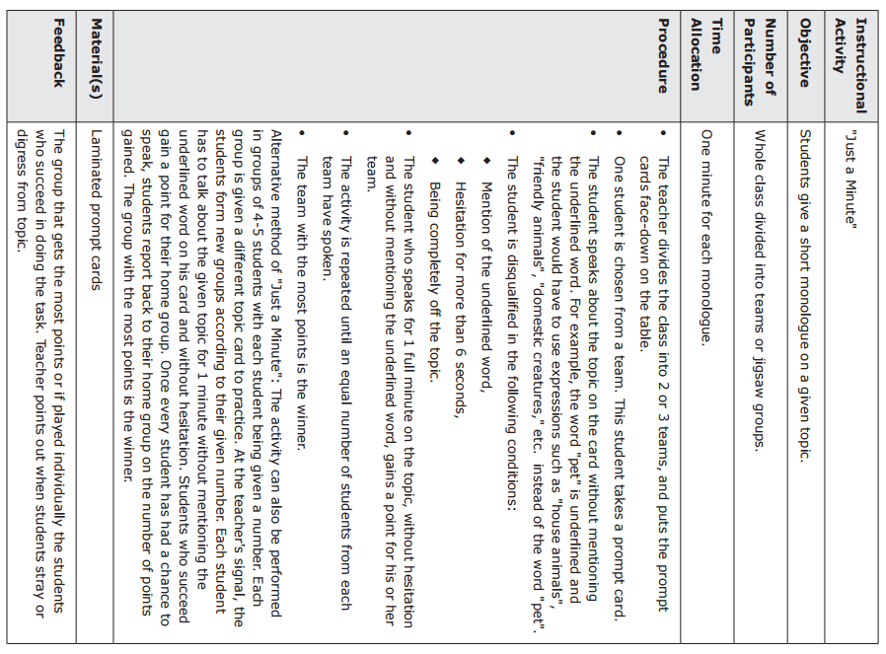

Rubric for the Student (with Hebrew if necessary)
Criterion | Remember | זכרו | קריטריון
Communicative  Ability | Make sure your meaning is clear to the listener.  Make sure that your responses match what was said before you responded.  Take turns during the conversation.  Try to keep the conversation going.  You may correct yourself as you speak,  or repeat what you said in different words. | וודאו שהמסר שלכם ברור לבן השיח שלכם.  וודאו שתגובותיכם מתאימות לְמה שנאמר לכם לפני  שהגבתם.  דברו לפי תורות בשיחה.  קדמו את השיחה שהיא תהיה  מתמשכת.  ניתן לעשות תיקון עצמי תוך כדי דיבור, או ניתן לחזור  במילים אחרות. | יכולת תקשורתית
Fluency | Pay attention to how smoothly you speak.  In other words, speak without hesitations and without long stops. | שימו לב לדיבור רציף. במילים אחרות, דברו ללא היסוס וללא עצירות ממושכות. | שטף דיבור
Pronunciation | You should pronounce the words correctly and pay attention to the stress patterns of the words. Your main aim is to make sure your listener understands what you are saying. | הקפידו על הגייה נכונה של המילים ושימו לב לדגשים  בתוך המילים. המטרה המרכזית היא שבן השיח יבין את מה שאתם אומרים. | הגייה
Language | Pay attention to  word order, verb  tenses, subject–verb agreement. | שימו לב לסדר המילים, זמנים  של פעלים, התאמת נושא– פועל. | דקדוק
Vocabulary | Choose your words  carefully. Make sure the words are appropriate or suited to your goals and to the context, and use a variety of words. | בחרו את המילים באופן זהיר. וודאו שהמילים מתאימות למטרותיכם ולהקשר, והשתמשו במגוון מילים. | אוצר מילים

Rubric for the Student (with Hebrew)
The rubric is the same except for "Communicative Ability".
Make sure your meaning is clear to the listener.
Make sure that your responses match what was said before you responded.
Take turns during the conversation.
Try to keep the conversation going.
You may correct yourself as you speak,or repeat what you said in different words.

For the Teacher — Checklist for Grading
The rubric is the same except for "Communicative Ability" –
The meaning was clear.
The mutual responses are appropriate.
There is turn taking during the conversation.
The conversation was sustained.

For the Teacher — Checklist for Grading
Criterion |  | Description | Level of Performance*
Communicative  Ability |  | The meaning was clear.  The mutual responses are appropriate.  There is turn taking during the conversation.  The conversation was sustained. | 4 | 3 | 2 | 1
Fluency |  | Speech flowed smoothly | 4 | 3 | 2 | 1
Pronunciation |  | Speech was intelligible. | 4 | 3 | 2 | 1
Vocabulary |  | The words and chunks chosen were appropriate and conveyed meaning clearly. | 4 | 3 | 2 | 1
Language |  | The grammar was mostly appropriate and correct. | 4 | 3 | 2 | 1

* 4 = greatly 3 = very much 2 = to some extent 1 = hardly at all

Unit 5 - Presenting Information Taken

from Different Sources

Presentation 1 - A Country
In this task, you will give an oral presentation in which you present
information about a country.
Work according to the following:
• Collect information about a country you are familiar with, or one that interests you and you want to learn more about. Include 2-3 facts each about its geography, history, weather, language,
currency, interesting sites, special attractions, things to do, etc.
• Prepare a poster or PowerPoint presentation with relevant
information. Suggested sources include newspapers, magazines and interviews with people who have information about the
topic you have chosen.
• Give an oral presentation about the country to the class and teacher.
The presentation should be five minutes long. Use the poster or
PowerPoint presentation to illustrate your ideas.

Presentation 2 - A Person You Admire
In this task, you will give an oral presentation in which you present
information about a person you admire.
Work according to the following:
• Collect information about a person you admire and you want to learn more about. Include information related to their personal background, their achievements, their qualities, what you admire about the person, etc.
• Prepare a poster or PowerPoint presentation with relevant
information. Suggested sources include newspapers, magazines and interviews with people who have information on the topic
you have chosen.
• Give an oral presentation about the person you admire to the class and teacher. The presentation should be five minutes long. Use the poster or PowerPoint presentation to illustrate your ideas.

Presentation 3 - A School Trip
Your class usually goes on a trip every year. This year the principal would like to learn more about the kind of trip students enjoy. Find out what kind of trip your friends want. To do this, prepare a questionnaire to find out what your friends think about:
• Places to visit
• When to go on the trip
• Means of transport
• Activities
Present your questions orally to at least ten students.
Write down their answers.
Analyze the results by adding up the students' answers. For example, for the first item (Places to visit) add up how many students wanted to visit Jerusalem. You might want to use a bar graph or pie chart to present the numbers/results/data.
Prepare a five-minute talk reporting your results.

Presentation 4 - How does Your Class Rate in "Chessed"?
"Chessed" is an activity performed by volunteers for the benefit of others. In other words, volunteers help people who need help.
Students in your class may be involved in "chessed".
You want to learn about the "chessed" done by your class. To do this, prepare a questionnaire to find out who does the following:
• Shopping for people
• Cleaning for people
• Reading to blind/sick/old people/young children
• Helping students with homework
• Free babysitting
• Cooking and baking for special events
Present your questions orally to at least ten students.
Write down their answers.
Analyze the results by adding up how many students chose each item you presented. You might want to use a bar graph or pie chart to present the numbers/results/data.
Prepare a five-minute talk reporting your results.

Rubric for the Student (with Hebrew if necessary)
Criterion | Remember | זכרו | קריטריון
Content | Collect and present  information that is  relevant and covers  different aspects of the  topic. | אספו והציגו מידע שהוא רלוונטי לנושא ומכסה היבטים שונים של הנושא. | תוכן
Language | Pay attention to word order, verb tenses, subject–verb agreement. | שימו לב לסדר המילים, זמנים של פעלים, התאמת  נושא-פועל. | דקדוק
Vocabulary | Choose your words  carefully. Make sure the  words are appropriate  or suited to your goals  and to the context, and  use a variety of words. | בחרו את המילים באופן זהיר. וודאו שהמילים מתאימות למטרותיכם ולהקשר והשתמשו במגוון  מילים. | אוצר מלים
Organization | Organize all the  information collected in  a way that is logical and  easy for the audience to  follow. | ארגנו את המידע שנאסף באופן לוגי כדי שיהיה קל לקהל לעקוב אחרי התוכן. | ארגון
Delivery | Speak loudly enough so  the audience will hear  you, make eye contact  with your audience,  make sure visual aids  match the content. | דברו בקול כך שהקהל יוכל לשמוע, יצרו מגע עין עם הקהל, וודאו שחומרי העזר מתאימים לתוכן. | העברה

For the Teacher — Checklist for Grading
Criterion | Description | Level of Performance*
Content | The information and explanations were relevant to the topic and covered many aspects of the topic. | 4 | 3 | 2 | 1
Organization | The information was presented in a logical sequence and it was easy for the audience to follow. | 4 | 3 | 2 | 1
Delivery | The student spoke loudly enough for the audience to hear, made eye contact with the audience, and used visual aids that suited the content. | 4 | 3 | 2 | 1
Vocabulary | The words and chunks chosen were appropriate and conveyed meaning clearly. | 4 | 3 | 2 | 1
Language | The grammar was mostly appropriate and correct. | 4 | 3 | 2 | 1
* 4 = greatly 3 = very much 2 = to some extent 1 = hardly at all

For the Student – Peer Assessment Form
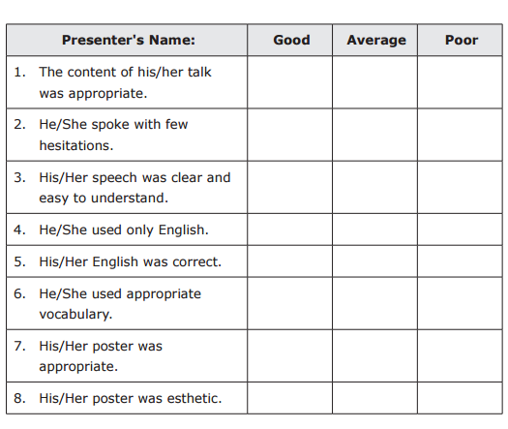

Instructional Activity | Trivia Hunt
Objectives | Students search for and locate information from different sources
Number of Participants | Whole class divided into groups of 3
Time Allocation | About 20-25 minutes
Procedure | *The teacher gives each group a worksheet with a list of trivia questions. Each group of students must answer the questions within a set time (teacher discretion).  *Each group of students must use at least different 3 sources.  *Each group fills out the worksheet, which includes the answer to each of the questions and the source that was used to find the answer (e.g. name of book and page number, name of person and signature, page from atlas/phone book/encyclopedia entry and page number, etc.).
Materials | Worksheet (teacher prepared)
Feedback | Teacher checks on the number of sources used, which the students felt most comfortable with, which were the most difficult to use, which were new to them, and which they would use again and why.

***Special thanks to Mrs. Esther Esses, who went through Unit 1 and adapted the appropriate parts for Charedi students.
For more useful material: tinyurl.com/charedienglish
For the entire ASK KIT: http://cms.education.gov.il/EducationCMS/Units/Rama/AarachaBeitSifrit/Erka_Safa_Dvora.html

