**Mama's Bank Account**

**Student Unit – 3 points**

**Pre-reading:**

1. You have 200 shekels. You want to buy:

* a birthday present for your mother
* food for the school trip
* a book
* a wallet

Fill in the chart with the things you want to buy in order of most important to least important. Write how much each will cost.

|  |  |
| --- | --- |
| **Want to buy:** | **It costs:** |
| 1. Most important |  |
| 2. |  |
| 3. |  |
| 4. Least important |  |

Do you have enough money to buy everything?

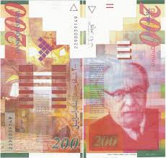

B. Look at these pictures:

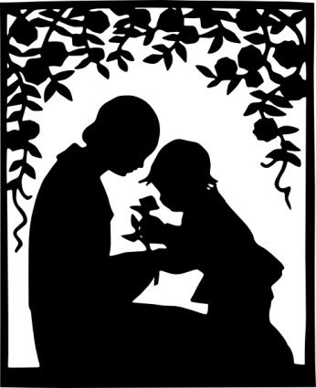1 2

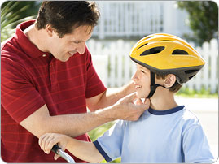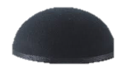

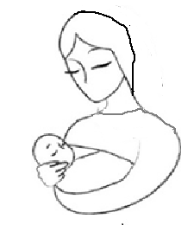

3 4

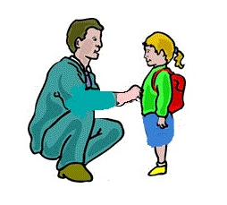

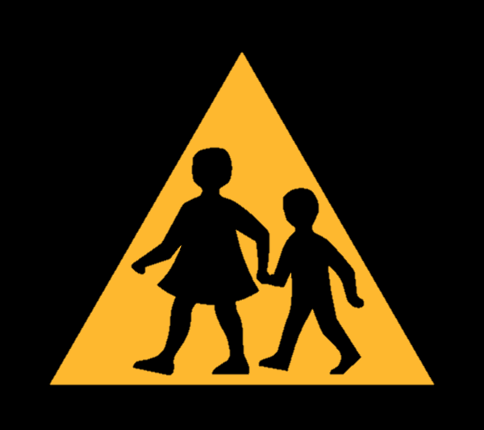5 6

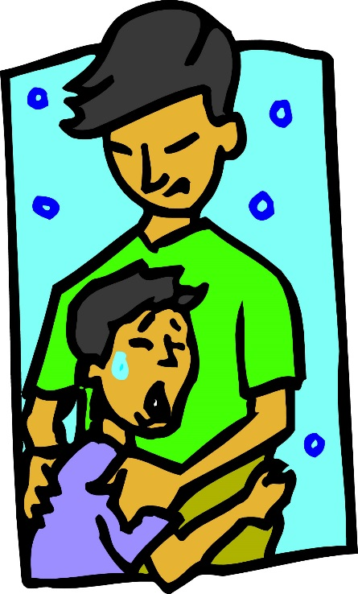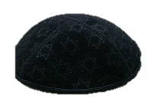

Now match each picture with a sentence:

1. The father is comforting his crying son. ______
2. The mother is holding her baby. ______
3. The mother and daughter are sharing a special moment. ______
4. The father is closing his daughter's jacket. ______
5. The mother is taking her son across the street. ______
6. The father wants his son to be safe on his bicycle. ______

**What do parents do to make their children feel loved and safe?**

__________________________________________________________

**Basic Understanding:**

Vocabulary

|  |  |
| --- | --- |
| Familiar |  |
| Piles, piling |  |
| Repaired |  |
| Secure, insecure |  |
| Rent |  |
| Ashamed |  |
| Emergencies |  |
| Supplies |  |
| Volunteered |  |
| Look after |  |
| Draw money |  |
| Knowledge |  |
| Depend upon |  |
| Noticed |  |
| Seriously |  |

Vocabulary Exercises

1. Fill in the missing words. Use the words above:
2. When my mother is at work, I ____________ my little sister.
3. Do you feel well? I ____________ that you are very tired.
4. Shimon is buying a car so he went to the bank to ____________ out of his account.
5. Children ____________ their parents to take care of them.
6. Sara ____________ to help her sister cook for Shabbat.
7. Learning Torah gives us important ____________.
8. When my car didn't start, Yosef ____________ it many times. He is ____________ with all its problems.
9. True or False?
10. We shouldn't take **emergencies seriously**. _________
11. If we have a big **pile** of money maybe we are rich. ____________
12. Someone might feel **secure** and **ashamed** if he can't pay the **rent**. ____________
13. We can buy **supplies** in a store. ____________

Comprehension Questions

1. How many children are in the family? What are their names?

___________________________________________________________________

1. What did the family do every Saturday night?

___________________________________________________________________

1. Name two things that the family needs money for.

___________________________________________________________________

1. What happened to the Jensen family? Why?

___________________________________________________________________

1. How did Christine reassure Katrin?

___________________________________________________________________

1. What is the "Little Bank"?

___________________________________________________________________

1. Name two times that the family took money from "Little Bank".

___________________________________________________________________

1. Why did the family have to take all the money from the "Little Bank"?

___________________________________________________________________

1. How did each person in the family help make more money?

___________________________________________________________________

___________________________________________________________________

1. How did Mama and Papa make money when Papa wasn't working?

___________________________________________________________________

1. Did the family ever have to go to the bank? Why?

___________________________________________________________________

1. Katrin got a check. Where did it come from?

___________________________________________________________________

1. Why did she give the check to Mama?

___________________________________________________________________

1. Why can't Mama put the check in her bank account?

___________________________________________________________________

1. Why did Mama tell the children that she had money in the bank?

___________________________________________________________________

**Analysis and Interpretation** **– Part I**

1. Do you think Mama did the right thing by lying to her children? Why or why not?

_________________________________________________________________

1. Do you think Papa knew the truth about the bank account? How do you know?

_________________________________________________________________

**Analysis and Interpretation – Part II**

**HOTS: Comparing and Contrasting**

Look at the pictures. How are they the same and how are they different?

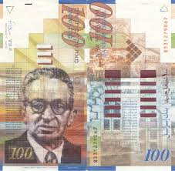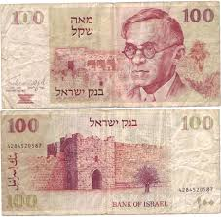

Fill in the Venn diagram.

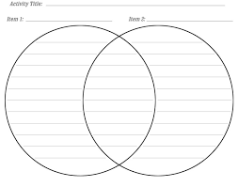

Now compare the way Katrin's family made, saved and spent money to the way people do these things today.

|  |  |  |
| --- | --- | --- |
|  | **Katrin's Family** | **People Today** |
| **How they make money** |  |  |
| **How they save money** |  |  |
| **How they spend money** |  |  |

**Literary Terms**

Character – A person in the story

Setting – When and where the story takes place

Who are the main characters in this story?

________________________________________________________________________

Where did the story happen?

________________________________________________________________________

When did the story happen?

________________________________________________________________________

**Bridging Text and Context**

Kathryn Forbes was born in California, U.S.A. in 1908. She was the granddaughter of people who came from Norway. She wrote Mama'sBank Account, a fiction story aboutNorwegians living in San Francisco in the 1920s. The story focuses on the family, its struggles and its dreams. It was so popular that it was made into a play, a movie and a television show.

How does this information help you understand the text better?

__________________________________________________________________

__________________________________________________________________

**Post – Reading**

Choose one:

1. You are Katrin. Write in your diary telling about your discovery that your parents never had a bank account.
2. Draw the story in comic form.

**Mama's Bank Account**

**Teacher's Guide – 3 points**

****It's recommended that the teacher divide this story into two parts.

**Pre-reading**

These are the points we want to get across to the students before reading the story.

A.

1. How does someone decide how to spend money?
2. What is a budget? Is it important?
3. Do you think everyone has one?
4. What do parents do to help their children feel loved and safe?

**Basic Understanding**

Vocabulary

The words in the table should be defined with the teacher and memorized for future use.

The following words are necessary for understanding the story, so they should be glossed. Students shouldn't be required to learn them.

1. Scrubbed
2. Landlord
3. Grocer
4. Solemnly
5. Eagerly
6. Pipe, tobacco
7. Figure
8. Milestone
9. Comforting
10. Strike
11. Teller
12. Deposit

**Vocabulary exercises**

Make sure the students understand the instructions. These exercises could be done before or after reading the story.

**For Additional Vocabulary exercises**

See the end of this unit.

**Comprehension questions**

It's recommended that teachers constantly check comprehension during the reading of the story.

****These questions are not meant to be answered all at once at the end of the story!

**Analysis and Interpretation – Part I**

Students should be able to draw conclusions based on the text.

**Analysis and Interpretation – Part II - HOTS: Comparing and contrasting**

The first part should be done as a class (perhaps on the board). The second part can be done individually or in pairs. Give the students these hints: Think about banks, cash, credit cards, payments….

**Literary Terms**

Students should be familiar with these basic terms.

**Bridging Text and Context**

This is one of the key components in the literature unit. However, it is not tested on the external exam.

**Post-Reading**

The teacher should decide on the length of the assignment.

**Summative Assessment**

See the next page.

***The teacher should read the test and make sure all the questions have been covered in class.

**Additional Vocabulary exercises**

Choose the correct word:

1. I studied ______________ for the test because I want a good grade.
2. seriously b. supplies c. ashamed
3. I studied for the test and now I have a lot of ______________.
4. rent b. knowledge c. piles
5. Yakov is my best friend. I ______________ him to help me in an emergency.
6. depend on b. notice c. repair
7. Yakov is my best friend. I am ______________ with what he does and doesn't like.
8. piling c. familiar c. look after
9. We volunteered to ______________ the baby when his mother was sick.
10. draw money b. insecure c. look after

**Mama's Bank Account – Summative Assessment**

**Part 1 – LOTS – (60 points)**

1. Choose the correct answer: (5x6=30)
2. Mothers want their children to feel______________.
3. secure b. volunteered
4. If there is an ______________ call the police.
5. ashamed b. emergency
6. We ______________ Hashem to look after us.
7. depend upon b. seriously
8. My father pays the ______________ on Rosh Chodesh.
9. rent b. pile
10. Do I know you? You look ______________.
11. familiar b. repaired

B. Answer the questions:

1. Why did Mama make a pile of coins every Saturday night? (7 points)

1. She needed to know how much money to put in the bank.
2. She needed to pay all of the family expenses.
3. She needed to give money to her children

2. The children helped make more money for the family. Give one example. (8 points)

___________________________________________________________________

1. The two most important piles of money were for…. (7 points)
2. Rent and food
3. Schoolbooks
4. Shoe repairs
5. Katrin wanted Mama to put her check into the bank account, but….(8 points)
6. Mama closed the account
7. There was no account
8. Mama said she doesn't want the money

**Part 2 – HOTS – (40 points)**

1. At the end of the story, Katrin found out Mama's secret. Does this change her opinion about her parents? (10 points)

a. Yes, she is hurt because they lied to her all the years.

b. No, she understands they wanted their children to be happy.

c. Yes, she thinks her parents need to open a bank account.

2. Compare and contrast: (3x10=30 points)

|  |  |  |
| --- | --- | --- |
| **Action** | **Compare these people…..** | **To these people…….** |
| Paying rent | Katrin's family __________ ______________________ | The Jensens _____________ ________________________ |
| Helping to make money | Katrin's parents __________ _______________________ | The children _____________ _______________________ |
| Saving money | Katrin's family __________ ______________________ | People today ____________ _______________________ |

**Good luck!**